 

National Aeronautics and DAPHNE-TP-0002

Space Administration EFFECTIVE DATE: 09/13/2016

**Space Communications and Navigation (SCaN)**

National Aeronautics and Space Administration

SCaN Project

Acceptance Test Procedure   
for the Near Earth Network (DAPHNE)

Rev 2 13 September 2016

|  |  |
| --- | --- |
| AUTHORIZED by CM when under FORMAL Configuration Control | |
| Date | Signature |
|  |  |

|  |  |  |  |
| --- | --- | --- | --- |
| ***Distribution:*** |  |  |  |
| [ ] NASA (U.S. Gov. Only) | [ ] Project Only | [ X ] Government and Contractors | |
| ***Availability:*** |  |  |  |
| [ X ] Public (No Restriction) | [ ] Export Controlled | [ ] Confidential/ Commercial | [ ] Internal Use Only |

**PREFACE**

National Aeronautics and Space Administration (NASA) Near Earth Network (NEN) Gateway provides an alternative approach to data delivery for the NEN. The DAPHNE is a high speed science data recorder and near real-time data delivery system.

The DAPHNE provides a cost effective way to collect high speed science data at the ground station and deliver this data via IP file transfer protocols to an end customers missions operation center (MOC). For Phase I, Interface Region Imaging Spectrograph (IRIS) support, the DAPHNE will be located at the NEN Wallops Ground Station (WGS) and the Alaska Satellite Facility (ASF) and initially supports only downlink data processing from IRIS.

This document provides a test procedure to insure that the instrument is meeting all the requirements for its operational readiness to support IRIS.

**DOCUMENT HISTORY LOG**

|  |  |  |  |
| --- | --- | --- | --- |
| **Status**  **(Preliminary/**  **Baseline/**  **Revision/**  **Canceled)** | **Document**  **Revision** | **Effective**  **Date** | **Description** |
|  |  |  |  |
|  |  | 12/01/2014 | Early version of document. |
| 1 | 2 | 9/13/16 | Second Rev based on 2012 version. Updated procedures. Changed document reference from SCNS-NEN-PLAN-0001 to NENG-TP-0002 also changed file names to avoid confusion with the test plan document and for agreement with the document tree. |
|  |  |  | Updated to apply to DAPHNE |
|  |  |  |  |
|  |  |  |  |
|  |  |  |  |
|  |  |  |  |
|  |  |  |  |
|  |  |  |  |

**SIGNATURE PAGE**

***Prepared By:***

|  |  |  |
| --- | --- | --- |
|  |  |  |
| **Alimayo Muhammad** |  | Date |
| DAPHNE Lead System Test Engineer  NASA Goddard Space Flight Center |  |  |
|  |  |  |

***Concurred By:***

|  |  |  |
| --- | --- | --- |
|  |  |  |
| **Martin Perrine** |  | Date |
| DAPHNE System Engineer |  |  |
| NASA Goddard Space Flight Center |  |  |

|  |  |  |
| --- | --- | --- |
|  |  |  |
| **Deepak Kaul** |  | Date |
| DAPHNE Lead Software Engineer |  |  |
| NASA Goddard Space Flight Center |  |  |
|  |  |  |
| **Alan T Schonbrunner** |  | Date |
| OPS/Testing/Network Engineer |  |  |
| NASA Wallops Flight Facility |  |  |

***Approved By:***

|  |  |  |
| --- | --- | --- |
|  |  |  |
|  |  |  |
|  |  |  |
|  |  |  |
|  |  |  |
| **Salem El-Nimri** |  | Date |
| DAPHNE Product Development Lead |  |  |
| NASA Goddard Space Flight Center |  |  |
|  |  |  |

TABLE OF CONTENTS

1 INTRODUCTION, Purpose, and Scope 1

2 Tools and Test Equipment Required AND SPECIAL HANDLING PROCEDURES 1

2.1 Preship Testing 1

2.2 Post-ship Testing 1

2.3 Electrostatic Discharge Requirements 1

2.4 Fiber Optic Cable Handling Requirements 1

3 Responsibilities 1

4 PROBLEM RECORDING AND RESOLUTION 2

5 Reference/aPPLICABLE DOCUMENTS 2

6 Acceptance TESTS 3

6.1 Preship tests 3

6.1.1 Basic Verification 3

6.1.1.1 Functional and Quality Tests 3

6.1.1.2 Specific Requirement Evaluation 4

6.1.1.3 Device under Test 14

6.1.1.4 Software/Hardware Configuration Setup 18

6.1.1.5 Test Setup 19

6.1.1.6 Processing Data 40

6.1.2 Disk I/O Test: 43

6.1.3 Removable Media Test 45

6.1.4 Logging Storage/ Memory Overflow Management Test 46

6.1.5 47

6.1.6 Latency Test 48

6.1.6.1 For the Requirement DAPHNE-PERF-001 Local cmd response 5 secs 48

6.1.6.2 For the requirement DAPHNE-PERF-002 loading configuration 120 secs 49

6.1.6.3 The requirement DAPHNE-PERF-003 Activation of return data 60 secs 50

6.1.6.4 DAPHNE-PERF-009 latency shall not exceed 3 minutes 50

6.2 Post Shipment Verification at Ground Station 53

6.2.1 Standards Test 54

6.2.2 Parallel Operational Testing 55

6.2.2.1 Basic Functionality and Data Quality 55

6.2.2.2 Specific Operational Requirement Verification 58

6.2.2.3 Performance Requirements 59

6.2.3 Self Service Functionality 63

6.2.4 Security Configuration Verification Test: 63

6.2.5 System Failure Mode Test 67

6.2.6 Pre-Ops Checkout: 68

APPENDIX A Requirements and Verification Matrix 70

APPENDIX B ACRONYMS AND ABBREVIATIONS 75

B.1 Scope 75

B.2 List of Acronyms and Abbreviations 75

APPENDIX C DEFINITIONS 79

C.1 Scope 79

C.2 List of Definitions 79

TABLE OF FIGURES

Figure 6‑1 ENG fop log showing automated delivery of .tlm and .qac files to simulated MOC. 5

Figure 6‑2 Linux window showing a test file called sample.txt created on the secure side of Unit2 primary irip5 7

Figure 6‑3 Linux window showing a test file created on the secure side of Unit2 primary irip5 does not exist on the open side at first but than is automatically created. 7

Figure 6‑4 Linux window showing a test file called sample.txt deleted from the secure side of Unit2 primary irip5 8

Figure 6‑5 Linux window showing a test file deleted on the secure side of Unit2 primary irip5 does exist on the open side at first but then is automatically deleted. 8

Figure 6‑2 DAPHNE excerpt showing status and statistics of total storage used for secure/open: 73% full (secure), 0% full (open) status and statistics for secure/open DUT Unit #1. 9

Figure 6‑3 Excerpt from syslog file showing DUT operational activity 11

Figure 6‑4 Excerpt from .html log file showing system failure activity 11

Figure 6‑5 Excerpt from beginning of dmesg file showing DUT configuration activity 12

Figure 6‑6 Excerpt from end of dmesg file showing DUT configuration activity 13

Figure 6‑7 DAPHNE Wiring diagram 15

Figure 6‑8 Rack showing one DAPHNE Unit in bottom of rack. 16

Figure 6‑9 Back panel of Dell server (fiber optic cables: red circle) 18

Figure 6‑10 Block diagram showing the test setup 19

Figure 6‑11 shows the Amergint Technologies SoftFEP Payload Processor 21

Figure 6‑12 shows the connections for the Samsung monitor from the Amerigent unit. The blue circle is a RGB connection using a VGA cable. The orange circle is the input connection for a mouse. The green circle is the input connection for a dell keyboard. 21

Figure 6‑13 Test controller, Dell Precision T3400 Tower Workstation showing Ethernet connection into the test network and interface connections. The blue circle is a RGB connection with a VGA cable. 22

Figure 6‑14 Netgear M7100-24X-ProSAFE 24 Ports 10G Fully Managed L2 Switch with connections for test equipment to the test network. The orange circle is the Ethernet cable to the Dell Precision T3400 Tower Workstation. 22

Figure 6‑15 Cortex Series Back Panel 23

Figure 6‑16 Cortex Series Back Panel 23

Figure 6‑17 Amergint Technologies SoftFEP Payload Processor Back Panel showing Ethernet connection to test network. 24

Figure 6‑18 Cortex Series Back Panel showing Ethernet connection to test network. 24

Figure 6‑19 Softfep Gui 25

Figure 6‑20 Import from Raw select 25

Figure 6‑21 Create Recording and create a **Recording Title** and **Recording Description** 26

Figure 6‑22 Select recorded file. 26

Figure 6‑23 Select the **Channel** to be HighRate. 27

Figure 6‑24 Add file created from the file library 27

Figure 6‑25 Select **Import Channel** 28

Figure 6‑26 Finish recording import. 28

Figure 6‑27 File ready for playback. 29

Figure 6‑28 connection to **localhost:1** 30

Figure 6‑29 Cortex Setup 30

Figure 6‑30 Cortex frame setup 31

Figure 6‑31 Cortex Real Time frame setup 31

Figure 6‑32 Cortex Global tab setup 32

Figure 6‑33 Cortex BER tab setup 32

Figure 6‑34 Cortex Decoding tab setup 33

Figure 6‑35 Cortex Modulation tab setup 34

Figure 6‑36Cortex PCM tab setup 34

Figure 6‑37 Test configuration window for Cortex 34

Figure 6‑38 Test configuration window for Cortex (cont) 35

Figure 6‑39 Loading IRIS_TEST configuration 36

Figure 6‑40 Closing configuration window 36

Figure 6‑41 Test Controller GUI test setup 38

Figure 6‑42 Controller GUI monitor showing VC2 and VC3 counts 39

Figure 6‑43 Screenshot of Cortex from 1 IRIS Pass 39

Figure 6‑44 AosCounterChecker script log excerpt showing VC2/VC3 counts and errors for DUT #1 LTT 42

Figure 6‑45 AOSCounterChecker example output for ASF_IRIS_2016_188_19_27_27.ldf, results for .qac and md5sum check for DUT output showing passed Checksum. 42

Figure 6‑46 shows the output after executing the disk_write_test.py script.The test is run directly on each server/Raid combination. 44

Figure 6‑47 shows the TestController log file that shows time for a setup command sent and time for a DAPHNE response . 49

Figure 6‑48 Test Controller screen shot showing short activation time. 50

Figure 6‑49 The file of interest is the largest (corresponding to the LTT) fep.log.1466025251. 51

Figure 6‑50 Contents of the largest file. 1465939462.raw is first file with frames. 51

Figure 6‑51 QCP log excerpt showing name of .tlm file created from 1465939462.raw. The VC03 is shown in the continued second panel showing the tlm file created ASF_IRIS_VC03_2016_166_21_14_47.tlm. 52

Figure 6‑52 Fop log showing sent time of filename: ASF_IRIS_VC03_2016_166_21_14_47.tlm 52

Figure 6‑53 DAPHNE Parallel Test Configuration 55

Figure 6‑54 DAPHNE Sample Log File 55

Figure 6‑55 DAPHNE M&C GUI 55

Figure 6‑56 Key Log segments examples (a) & (b) from CTL log file, (c) from FEP Log file, and (d) from FOP Log file 57

Figure 6‑57 DAPHNE Banner 60

Figure 6‑58 DAPHNE M&C GUI with a failure 62

Figure 6‑59 File permission 63

LIST OF TABLES

Table 1 Reference Documents 2

Table 2 The DAPHNE rack with model and serial numbers. 17

Table 3 lists the equipment in the lab test rack. In addition, standalone desktop computers running LINUX were used as the test controller and for the Amerigent. 20

Table 4 Disk IO Test 44

Table 5 Copy File to a Removable Desk Media 46

Table 6 Logging Storage Test 47

Table 7 Parallel Test check points 58

Table 8 Log entry 59

Table 9 Verification Table 61

Table 10 System Failure Test 62

Table 11 Verification Table 64

APPENDIX

Table B-1—Acronyms 69

Table C-1—Definitions 73

# INTRODUCTION, Purpose, and Scope

This is the acceptance test procedure for the Near Earth Network (NEN) Gateway System (DAPHNE). The purpose of this document is to test the full system and insure that it is operational, and that all the requirements are met. The full definition of each (*mission*) interface is given in the appropriate (*mission*) Interface Control Document (ICD).

# Tools and Test Equipment Required AND SPECIAL HANDLING PROCEDURES

## Preship Testing

The special test equipment for the pre-ship testing is described in section 6.1.1. The equipment in summary is an Amerigent data input unit, a Cortex IF receiver with test source, and a control computer running special test and processing scripts.

## Post-ship Testing

Post shipment testing is performed in the parallel with the current operational system. No special equipment is needed for these tests. The parallel operation is accommodated by configuring the network IP connections for parallel operations.

## Electrostatic Discharge Requirements

This hardware contains **internal** components that are sensitive to ESD. ESD precautions will be observed in accordance with the GSFC Electrostatic Discharge (ESD) Control Plan (300-PG-8730.6.1) and all personnel will be certified as per the Goddard Procedural Requirement “Electrostatic Discharge (ESD) Control” (GPR 8730.6). In order to protect the hardware from ESD, wrist straps shall be worn by all personnel within one (1) meter of the electronics when **internal** access is required to repair or modify the server i.e. ram, fan, motherboard etc. Each wrist strap shall be tested by the user at each usage and connected to an approved facility ground. All Alternating Current (AC)-powered Electrical Ground Support Equipment (EGSE) connected to the hardware shall be grounded to the same facility ground.

## Fiber Optic Cable Handling Requirements

This hardware contains components that require handling sensitive fiber optic cables. We recommend handling these with great care. Using procedures in the “Fiber optic terminations, cable assemblies, and Installation” (NASA-STD 8739.5) is recommended.

# Responsibilities

Left Blank

# PROBLEM RECORDING AND RESOLUTION

All problems noted should be recorded and reported to the PDL when they are encountered.

# Reference/aPPLICABLE DOCUMENTS

Reference documents are those documents that, though not a part of this document, serve to clarify the intent and contents of this document. See Table 1.

Table Reference Documents

|  |  |  |
| --- | --- | --- |
| **Reference ID** | **Document Number** | **Reference Document** |
| RD 01 | SCNS-NEN-SPEC-0001 | Design Specification for the NENGTask |
| RD 02 |  | Requirement Specification for DAPHNE |
| RD 03 | 566-DAPHNE-TPlan-0001 | Test Plan for the DAPHNE |
| RD 04 | 453-ICD-IRIS/DAPHNEG | NEN ICD Between DAPHNE and IRIS MOC |
| RD 05 | NASA-STD 8739.5 | Fiber optic terminations, cable assemblies, and  Installation |
|  |  |  |
| RD07 | 300-PG-8730.6.1 | GSFC Electrostatic Discharge (ESD) Control Plan (300-PG-8730.6.1) |

# Acceptance TESTS

## Preship tests

This section provides the test procedures to be used prior to shipment of the DAPHNE to the NEN field station for the IRIS mission. This procedure is based on testing for the NEN Gateway sent to ASF in July of 2016. Adjustments to the procedure as appropriate for DAPHNE are expected. Adjustments for the NISAR mission are also expected.

### Basic Verification

#### Functional and Quality Tests

**Purpose:**

To insure that the DAPHNE meets the basic operational functional requirements.  This test will also indicate quality assurance of the data.

Device under Test (DUT):

DAPHNE units are configured for the IRIS mission.  Primary and backup configurations are tested.

**Configuration for IRIS test support**:

The setup tests operations by receiving actual data from the Cortex HDR IF receiver as it would during normal operations, processing the data, and sending the data to an MOC.  The MOC is simulated by creating an IP location on the Amerigent data source memory.  The NASA Integrated Service network (NISN) is simulated by the 566 lab network.

Test data files are generated using special scripts. Once these files are generated, they are loaded into the Amerigent SoftFEP software program. From the software program, they are fed to an Amerigent SoftFEP-7000 data system which buffers the data files and feeds them in a stream to an IF signal modulator.  The modulator used is actually built into the same Cortex receiver mentioned below, as a convenient test source. The signal has the data protocols added as required by the NEN and mission.  The modulated signal is fed into the Cortex IF receiver which demodulates the signal, and processes it to create AOS frames of data (deframed).  The AOS frames are than sent to the DAPHNE using TCP/IP protocol.  DAPHNE processes the data and automatically sends it to the simulated MOC via TCP/IP. All setup parameters are specific for the IRIS mission parameters.

Backup configurations are setup by changing the Raids IP address and physically moving the four fiber optic cables from the primary server to the backup server.  Details are shown in Figure 6‑13.

That signal generator and DAPHNE unit will both be set up to handle a simulated IRIS satellite over pass of 10 minutes.  This 10 minute pass will be continuously looped with a small gap at the end to simulate extended operations over numerous overpasses.

This test was repeated 4 times for the two units each having primary and backup configurations.  To ensure that the DAPHNE meets operability over a long period of time without any major issues a long set of data was taken with 130 passes each 10 minutes long for the primary equipment referred to as the long term test (LTT). A shorter set of 20 passes were taken for the backup equipment referred to as the short term test (STT).

Additional overpasses are also run.  These runs help bound an uncertainty in the test due to a known issue with the Cortex receiver holding a few of the frames in its buffer after signal is lost at the end of an overpass.

After the test is complete a custom Python script will be run to analyze the results.  The script called DataChecker which calls up another script called AOSCounterChecker performs the following checks for each entry of each DAPHNE .ldf file:

1. Counts the frames (VC02’s and VC03’s) and checks for total error frames
2. Calculates a checksum
3. Compares the checksum to the md5sum in the DAPHNE .qac file
4. Checks for large erroneous gaps between frames.

The script creates a results log files which outputs reports that contain:

1. Frame counts of each telemetry file DAPHNE creates listed in the DAPHNE .ldf file.
2. Number of errors detected

**PASS/FAIL criteria:**

The functional pass criteria is that processed VC frame counts are within 1000 of expected for all test overpasses.

The unit fails if processed VC frame counts are not within 1000 of expected.

The quality pass criteria is that processed VC frames do not contain any checksum differences from the original value for the files processed during the all test overpasses.

The unit fails if any checksum differences are noted.

**See the procedure below in 6.1.1.3 through 6.1.1.6.**

#### Specific Requirement Evaluation

In addition to the basic functional and quality test described in 6.1.1, this section will test for compliance with the following requirements listed in SCNS-NEN-REQT-0001. The LTT/STT will allow verification of these requirements:

NOTE: requirements table and corresponding procedures needs updating for DAPHNE

|  |
| --- |
| DAPHNE-OPS-001 automated data delivery |
| DAPHNE-OPS-002 Attempt data delivery once |
| DAPHNE-OPS-004 Unattended nominal operation |
| DAPHNE-OPS-007 autonomous operation |
| DAPHNE-OPS-010 Data transport to repository |
| DAPHNE-OPS-012 Secure to Open storage |
| DAPHNE-OPS-013 Storage system status |
| DAPHNE-OPS-013.1 Statistics provided by the DAPHNE storage system shall include, but not be limited to: total storage available for secure/open, total storage used for secure/open, disk health for secure/open, storage system health. |
| DAPHNE-OPS-014 The DAPHNE shall provide status via a TCP/IP stream for remote monitoring. |
| DAPHNE-OPS-015 Remote configurable |
| DAPHNE-OPS-016 System logs and failure logs |
| DAPHNE-OPS-018 The DAPHNE shall provide alerts to notify Operators of configuration changes. |
| DAPHNE-OPS-019 Operate in office/computer room |
| DAPHNE-PERF-006 Min Receive and process data rate 13.125 Mbps |
| DAPHNE-ServAssure-004 Log of file delivery attempt |

|  |  |
| --- | --- |
| ID | DSRR Requirement |
| NENG-OPS-001 | DAPHNE shall provide automated delivery of user data to authorized users. |
| NENG-OPS-002 | DAPHNE shall attempt automated delivery once. |
| NENG-OPS-004 | DAPHNE shall operate unattended. |
| NENG-OPS-013 | DAPHNE shall provide system status. |
| NENG-OPS-013.1 | DAPHNE storage system shall report: the total storage available secure/open, total storage used secure/open, disk health for secure/open, and storage system health. |
| NENG-OPS-015 | DAPHNE shall be remotely configurable via a TCP/IP. |
| NENG-OPS-016 | DAPHNE shall provide a system logging function to log system failure and operational activity. |
| NENG-OPS-019 | DAPHNE storage system shall operate in a NEN computer room environment. |
| NENG-OPS-024 | DAPHNE shall provide status via a TCP/IP for remote monitoring. |
| New | DAPHNE shall send user data in priority order during Automatic Delivery. |
| NENG-PERF-010 | DAPHNE shall receive and process two streams of telemetry data at a rate up to 2 Gbps each |
| NENG-ServAssure-004 | DAPHNE shall account for each file delivery attempt. |

The High level procedure for each requirement is given here. These all fall within the basic functional test. The log files given as example are from the NENG test in 2016 and may very with DAPHNE log files. Details as to the pass/fail criteria and verification methods are given.

**Requirement:**

DAPHNE-OPS-001 automated data delivery.

**PASS/FAIL criteria:**

The pass criteria is that the unit performs automated data delivery.

The unit fails if it does not perform automated data delivery.

Verification:

The test script used configures and starts the DAPHNE operations. Once started, the DAPHNE runs autonomously and no additional commands are sent to it during the overpass operation. Successful completion of the test confirms “automated delivery” of the data. Log files presented for the basic functional test demonstrate delivery of data to the MOC emulator, see Figure 6‑1 for an example. Compliance for unit 2 is verified by association with the successful basic functional test documented above. Parallel testing at the field station under operational conditions will also inherently demonstrate compliance.

**Result:**

Enter Pass/Fail



Figure 6‑1 ENG fop log showing automated delivery of .tlm and .qac files to simulated MOC.

**Requirement:**

DAPHNE-OPS-002 Attempt data delivery once.

**PASS/FAIL criteria:**

The pass criteria is that the unit attempts data delivery once.

The unit fails if it does not attempt data delivery once.

Verification:

The test script used configures and starts the DAPHNE operations. Once started, the DAPHNE runs autonomously. Successful completion of the test confirms transmission of the data. Log files presented for the basic functional test demonstrate delivery of data to the MOC emulator, see Figure 6‑1; Compliance for unit 2 is verified by association with the successful basic functional test documented above. Multiple copies of the data were never observed in the repository.

**Result:**

Enter Pass or Fail

**Requirement:**

DAPHNE-OPS-004 Unattended nominal operation.

**PASS/FAIL criteria:**

The pass criteria is that the unit supports unattended nominal operation.

The unit fails if it does not support unattended nominal operation.

Verification:

The test script runs the entire test from a lab workstation controlling computer via an IP connection that is remote from the DAPHNE. Successful completion of the test confirms unattended operations. Parallel testing at the field station under operational conditions will also inherently demonstrate compliance.

**Result:**

Enter Pass or Fail

**Requirement:**

DAPHNE-OPS-007 autonomous operation.

**PASS/FAIL criteria:**

The pass criteria is that the unit supports autonomous nominal operation.

The unit fails if it does not support autonomous nominal operation.

Verification:

The test script runs the entire test from a lab workstation controlling computer via an IP connection that is remote from DAPHNE. Once started with a single command the unit runs autonomously until the process is complete. Successful completion of the test confirms autonomous operations. Parallel testing at the field station under operational conditions will also inherently demonstrate compliance.

**Result:**

Enter Pass or Fail

**Requirement:**

DAPHNE-OPS-010 Data transport to repository.

**PASS/FAIL criteria:**

The pass criteria is that the unit transports data to a repository.

The unit fails if it does not transport data to a repository.

Verification: The log file in Figure 6‑1 shows that the data files were successfully delivered to the MOC simulator for unit 1. Compliance for unit 2 is verified by association with the successful basic functional test documented above. Parallel testing at the field station under operational conditions will also inherently demonstrate compliance.

**Result:**

Enter Pass or Fail

**Requirement:**

DAPHNE-OPS-012 Secure to open storage.

**PASS/FAIL criteria:**

The pass criteria is that the unit moves files from the secure storage to the open storage.

The unit fails if it does not move files from the secure storage to the open storage.

Verification:

Log files show that the data also exists on the open storage side for unit 1 and unit 2. See Figure 6‑2 through Figure 6‑5 as an example to demonstrate the fulfillment of this requirement. In the DAPHNE design, the open storage directories are automatically synchronized with the secure storage. Synchronization is separately verified under section 6.1.3.

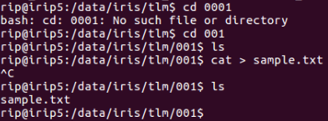

Figure 6‑2 Linux window showing a test file called sample.txt created on the secure side of Unit2 primary irip5

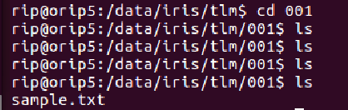

Figure 6‑3 Linux window showing a test file created on the secure side of Unit2 primary irip5 does not exist on the open side at first but than is automatically created.

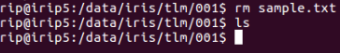

Figure 6‑4 Linux window showing a test file called sample.txt deleted from the secure side of Unit2 primary irip5

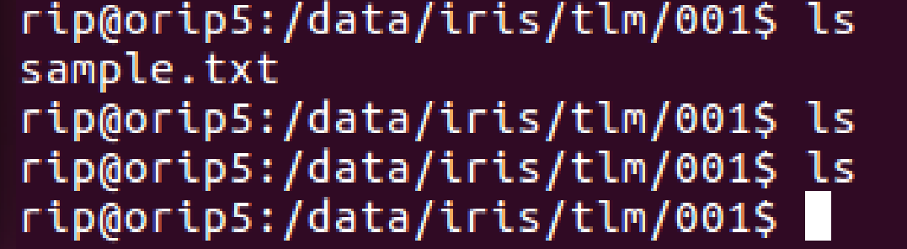

Figure 6‑5 Linux window showing a test file deleted on the secure side of Unit2 primary irip5 does exist on the open side at first but then is automatically deleted.

**Result:**

Enter Pass or Fail

**Requirement:**

DAPHNE-OPS-013 The DAPHNE shall provide system status.

DAPHNE-OPS-013.1 Statistics provided by the DAPHNE storage system shall include, but not be limited to: total storage available for secure/open, total storage used for secure/open, disk health for secure/open, storage system health.

**PASS/FAIL criteria:**

The pass criteria is that the DAPHNE shall produce log files by the DAPHNE storage system providing system status.

The unit fails if it the DAPHNE shall produce log files by the DAPHNE storage system providing system status.

Procedure for requirements DAPHNE-OPS-013, DAPHNE-OPS-013.1, DAPHNE-OPS-014:

1. Open terminal
2. Remotely ssh into server as ops user for DUT #1 Primary Side typing: ssh ops@1**.***.*.**0. **Note:** The * indicates there are other numbers for this IP address or a password.
3. Type *** for password.
4. Once logged in, type bash.
5. Type telnet localhost 4004
6. Type ! to display current status (once).
7. Procedure 1 through 5 shall be repeated for DUT #2, except the ssh login will be different. It will be ops@1**.***.*.**4. **Note:** The * indicates there are other numbers for this IP address or a password.

Example from DUT Primary:

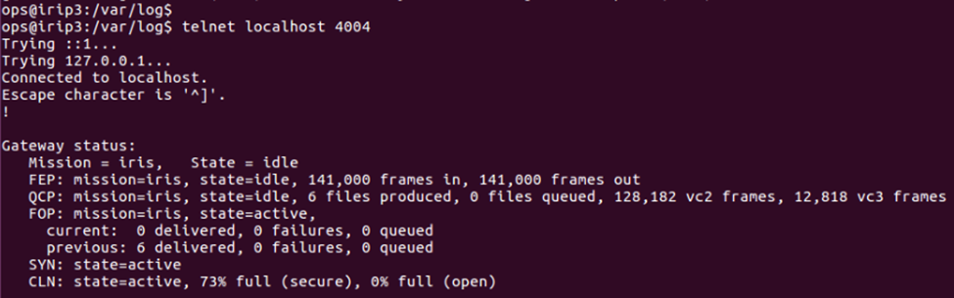

Figure 6‑6 DAPHNE excerpt showing status and statistics of total storage used for secure/open: 73% full (secure), 0% full (open) status and statistics for secure/open DUT Unit #1.

**Result:**

Enter Pass or Fail

**Requirement:**

DAPHNE-OPS-014 The DAPHNE shall provide status via a TCP/IP stream for remote monitoring.

**PASS/FAIL criteria:**

The pass criteria is that the DAPHNE shall produce log files providing system status from a TCP/IP stream for remote monitoring.

The pass criteria is that the DAPHNE shall not produce log files providing system status from a TCP/IP stream for remote monitoring.

Verification:

Log file shown in Figure 6‑6 shows the DAPHNE statistics for remote monitoring via a TCP/IP stream.

**Result:**

Enter Pass or Fail

**Requirement:**

DAPHNE-OPS-015 Remote configurable.

**PASS/FAIL criteria:**

The pass criteria is that the unit can be configured remotely.

The unit fails if it cannot be configured remotely.

Verification:

The test script used configures and starts the DAPHNE operations. The test script runs the entire test from a controlling computer via an IP connection that is remote from the DAPHNE. The DAPHNE is configured for the IRIS mission as part of this test. Successful completion of the test confirms remote configuration. Parallel testing at the field station under operational conditions will also inherently demonstrate compliance.

**Result:**

Enter Pass or Fail

**Requirement:**

DAPHNE-OPS-016 The DAPHNE shall provide a system logging function to log system failure and operational activity.

**PASS/FAIL criteria:**

The pass criteria is that the DAPHNE shall produce log files by the NEN system logging function showing system failure and operational activity.

The unit fails if it the DAPHNE does not produce log files by the NEN system logging function showing system failure and operational activity.

Procedure for requirement DAPHNE-OPS-016 (operational activity):

1. Open terminal
2. Remotely ssh into server as ops user for DUT #1 Primary Side typing: ssh ops@1**.***.*.**0. **Note:** The * indicates there are other numbers for this IP address or a password.
3. Type *** for password.
4. Once logged in, type bash.
5. Type cd /var/log
6. Type cat syslog. Figure 6‑7 and Figure 6‑8 shows the system log status. Record excerpts from this information.
7. Procedure 1 through 7 shall be repeated for DUT #2, except the ssh login will be different. It will be [ops@1**.***.*.**4](mailto:ops@1**.***.*.**4).

Procedure for requirement DAPHNE-OPS-016 (system failure):

1. Open a terminal
2. Log in
3. Assure account used has the appropriate permissions
4. Assure that the needed directory DAPHNE_testbed_GUI is accessible
5. To start DAPHNE GUI, type: ./Run.sh
6. Once the GUI comes up, before beginning a LTT or STT make sure the Cortex is reset to 0 frames send for transmitter and receiver
7. To begin a STT or LTT click the respective button to do so as it appears on the GUI.
8. While the STT or LTT is running, remove the fiber optic cable from the back of the Dell server illustrated in Figure 6‑13.
9. To view the system log file after the STT or LTT has completed, go to the following directory:

/home/pfettere/sandbox/DAPHNE_gateway_gui/DAPHNE_testbed_gui.git/DAPHNE_testbed_gui/log

1. Here all the logs are save for each and every STT or LTT ran.
2. Locate the most recent .html file excerpt and copy and paste it into a Firefox web browser. All the log information will be displayed from the STT or LTT pass. Figure 6‑8 shows the test controller html log with system failure activity.

Figure 6‑7 shows the DUT operational activity from the syslog file and Figure 6‑8 shows system failure activity from an .html log file. The red wording lists all the failed connection attempts to the sfep, cortex, port 4004, and even DAPHNE.

Example from DUT:

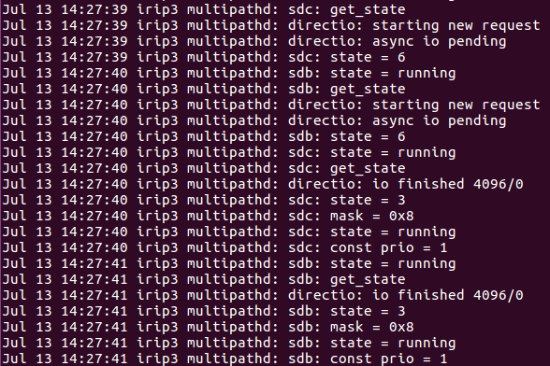

Figure 6‑7 Excerpt from syslog file showing DUT operational activity

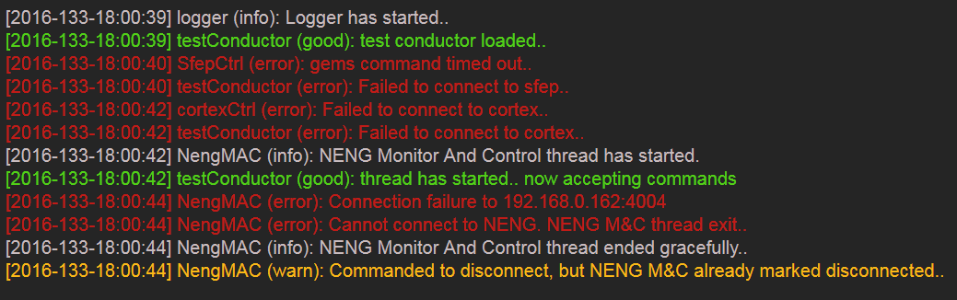

Figure 6‑8 Excerpt from .html log file showing system failure activity

**Result:**

Enter Pass or Fail

**Requirement:**

DAPHNE-OPS-018 The DAPHNE shall provide alerts to notify Operators of configuration changes.

**PASS/FAIL criteria:**

The pass criteria is that the DAPHNE alerts operators of configuration changes.

The unit fails if the DAPHNE does not alert operators of configuration changes.

Procedure for requirement DAPHNE-OPS-018:

1. Open terminal
2. Remotely ssh into server as ops user for DUT #1 Primary Side typing: ssh ops@1**.***.*.**0. **Note:** The * indicates there are other numbers for this IP address or a password.
3. Type *** for password.
4. Once logged in, type bash.
5. Type cd /var/log
6. Type cat dmesg. Figure 6‑9 and Figure 6‑10 shows the system log status. Record excerpts from this information.
7. Procedure 1 through 7 shall be repeated for DUT #2, except the ssh login will be different. It will be ops@1**.***.*.**4. **Note:** The * indicates there are other numbers for this IP address or a password.

Example from DUT:

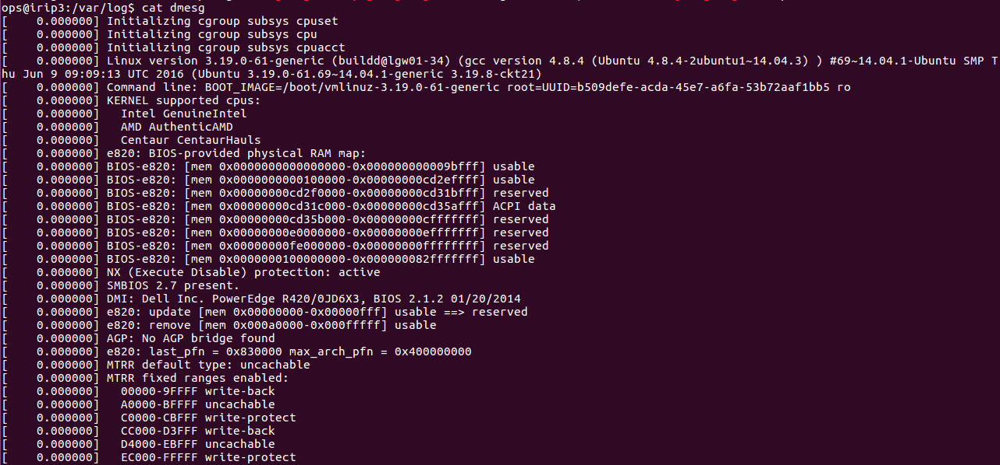

Figure 6‑9 Excerpt from beginning of dmesg file showing DUT configuration activity

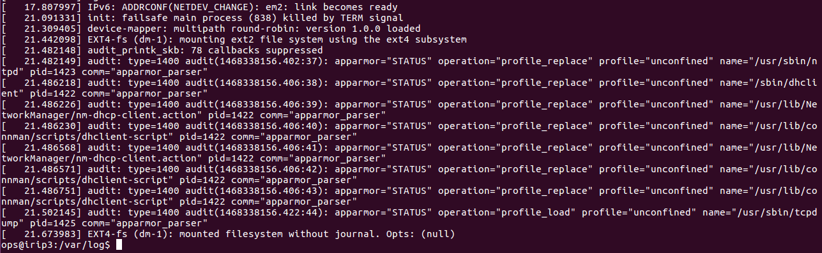

Figure 6‑10 Excerpt from end of dmesg file showing DUT configuration activity

**Result:**

Enter Pass or Fail

**Requirement:**

DAPHNE-OPS-019 Operate in office/computer room;

**PASS/FAIL criteria:**

The pass criteria is that the unit is able to operate in an office/computer room.

The unit fails if it is not able to operate in an office/computer room.

Verification:

The test is conducted within a 566 computer lab and inherently demonstrates compliance with this requirement.

**Result:**

Enter Pass or Fail

**Requirement:**

DAPHNE-PERF-006 Minimum Receive and process data rate 13.125 Mbps;

**PASS/FAIL criteria:**

The pass criteria is that the unit receives and processes data rate at ≥ 13.125 Mbps.

The unit fails if it unit receives and processes data rate at < 13.125 Mbps.

Verification:

The test in this section simulating the IRIS mission was successfully performed for Unit 1 and Unit 2. The IRIS missions uses a 13.125 Mbps rate. Cortex screen shots can demonstrate a test rate of 13.125 Mbps.

**Result:**

Enter Pass or Fail

**Requirement:**

DAPHNE-ServAssure-004 Log of file delivery attempt

**PASS/FAIL criteria:**

The pass criteria is that the unit logs file delivery attempts.

The unit fails if it does not log file delivery attempts.

Verification:

The delivery attempts are logged by DAPHNE automatically into log files shown in

Figure 6‑1 Compliance for unit 2 is verified by association with the successful basic functional test documented above.

**Result:**

Enter Pass or Fail

#### Device under Test

The device under test (DUT) is the DAPHNE unit as shown below. The wiring diagram is shown in Figure 6‑11. The delivery for this particular test July 2016 will be for two units installed in one rack. One DAPHNE unit is shown in Figure 6‑12 and Table 2 gives a listing of what’s inclusive in the rack.

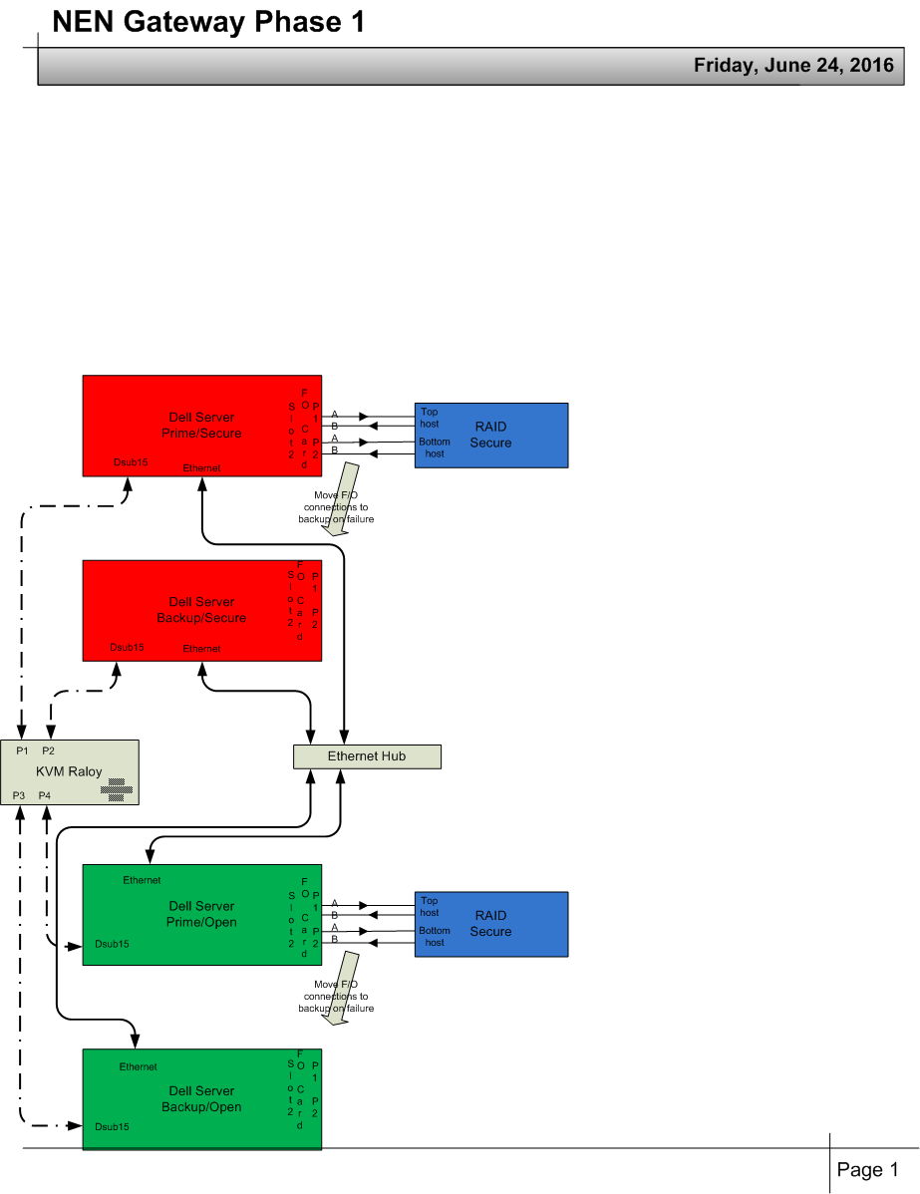

Figure 6‑11 DAPHNE Wiring diagram

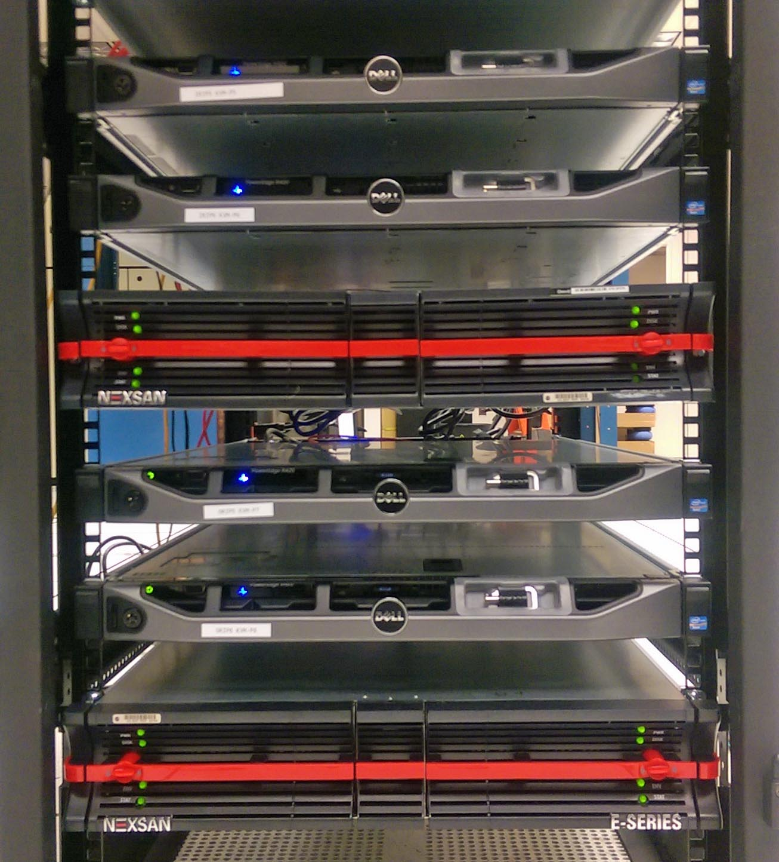

Figure 6‑12 Rack showing one DAPHNE Unit in bottom of rack. (needs replacement with DAPHNE)

The DAPHNE rack with model and serial numbers delivered to ASF for two units is given in Table 2.

Table The DAPHNE rack with model and serial numbers. (needs replacement with DAPHNE)

|  |  |  |  |  |
| --- | --- | --- | --- | --- |
| **Rack #22- DAPHNE** | **NAME** | **Govt. ID** | **Serial Number (S/N)** | **Model** |
| 31 | Dell Power Edge | N/A | 6GRKN22 | R420 |
|  |  |  |  |  |
| 29 | Dell Power Edge | N/A | 6GTJN22 | R420 |
|  |  |  |  |  |
| 27 | Nexsan E-Series | 2627041 | NXT3120006Y | E182-18/1 |
|  |  |  |  |  |
| 24 | Dell Power Edge | N/A | Unknown | R420 |
|  |  |  |  |  |
| 22 | Dell Power Edge | N/A | 6GYJN22 | R420 |
|  |  |  |  |  |
| 20 | RALOY | 2406564 | S1613310915101-0416G001 | W119-S801e |
|  |  |  |  |  |
| 18 | Nexsan E-Series | 2625137 | NXT319000F6 | 3500335 |
|  |  |  |  |  |
| 15 | Dell Power Edge | N/A | 6GTHN22 | R420 |
|  |  |  |  |  |
| 13 | Dell Power Edge | N/A | 6GYKN22 | R420 |
|  |  |  |  |  |
| 11 | Nexsan E-Series | 2625136 | NXT319000FR | 3500335 |
|  |  |  |  |  |
| 8 | Dell Power Edge | N/A | 6GSHN22 | R420 |
|  |  |  |  |  |
| 6 | Dell Power Edge | N/A | 6GWJN22 | R420 |
|  |  |  |  |  |
| 4 | Nexsan E-Series | 2627036 | NXT31200073 | E182-18/1 |

#### Software/Hardware Configuration Setup

Backup configurations are setup by changing the Raids IP address and physically moving the four fiber optic cables from the primary server to the backup server.  See Figure 6‑13.

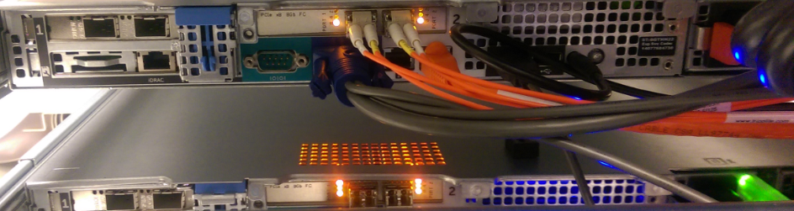

Figure 6‑13 Back panel of Dell server (fiber optic cables: red circle) (needs replacement with DAPHNE)

In addition the configuration of the data path has to be changed including the IP addresses. The following script issued from the path: /home/Alimayo/sandbox/DAPHNE_testbed_GUI.git/DAPHNE_testbed_GUI

1. Open DAPHNEw_monitor.py using a text editor of choice.
2. Find # DAPHNE configuration text in script
3. Change the self.DAPHNE_ip variable to the location of DAPHNE server under test Setup

#### 

Block diagram showing the test setup is shown in Figure 6‑14.

|  |
| --- |
| Figure 6‑14 Block diagram showing the test setup(needs replacement with DAPHNE)    Table lists the equipment in the lab test rack. In addition, standalone desktop computers running LINUX were used as the test controller and for the Amerigent. |

The test setup configuration follows:

The set of figures from Figure 6‑15 through Figure 6‑22 show the connections of the Amerigent, controller computer, test network and the Cortex receiver.

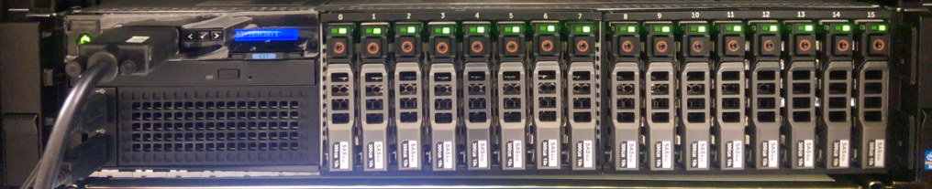

Figure 6‑15 shows the Amergint Technologies SoftFEP Payload Processor

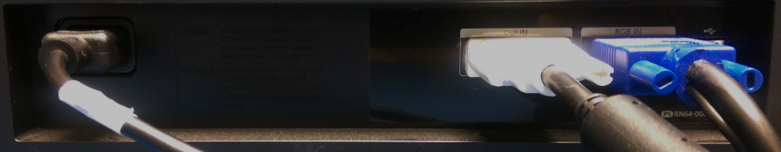

Figure 6‑16 shows the connections for the Samsung monitor from the Amerigent unit. The blue circle is a RGB connection using a VGA cable. The orange circle is the input connection for a mouse. The green circle is the input connection for a dell keyboard.

1. 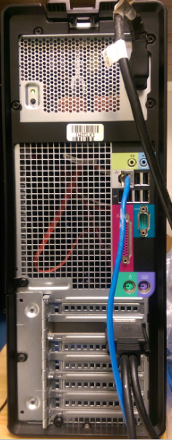

Figure 6‑17 Test controller, Dell Precision T3400 Tower Workstation showing Ethernet connection into the test network and interface connections. The blue circle is a RGB connection with a VGA cable.

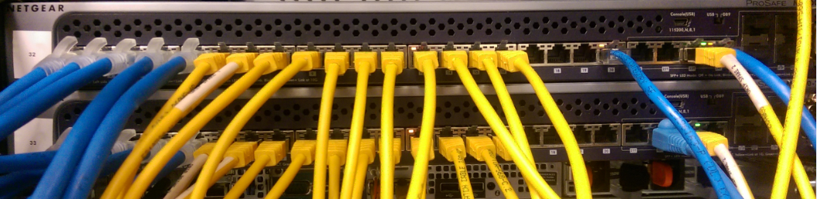

Figure 6‑18 Netgear M7100-24X-ProSAFE 24 Ports 10G Fully Managed L2 Switch with connections for test equipment to the test network. The orange circle is the Ethernet cable to the Dell Precision T3400 Tower Workstation.

Figure 6‑19 shows the Amerigent data and clock connections to be made to the Cortex back panel Figure 6‑20.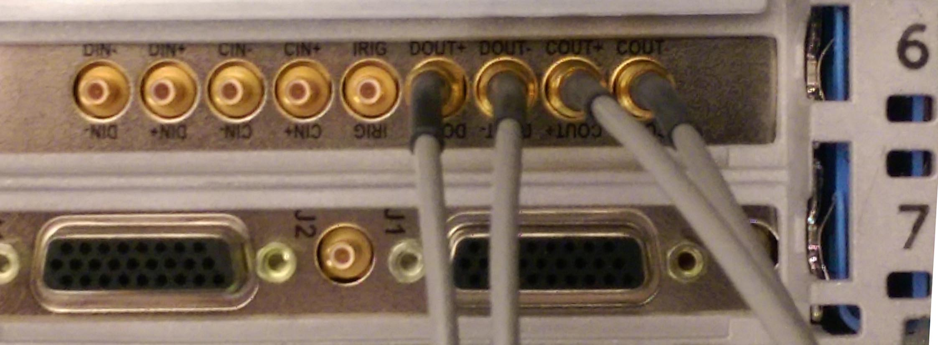

Figure 6‑19 Cortex Series Back Panel

The red circle in is the Dout + output which goes to input of the Cortex at J3 IN 1+.

The yellow circle is the Dout - output which goes to input of the Cortex at J4 IN 1-.

The green circle is the Cout + output which goes to input of the Cortex at J1 CLK +.

The blue circle in is the Cout - output which goes to input of the Cortex at J2 CLK -.

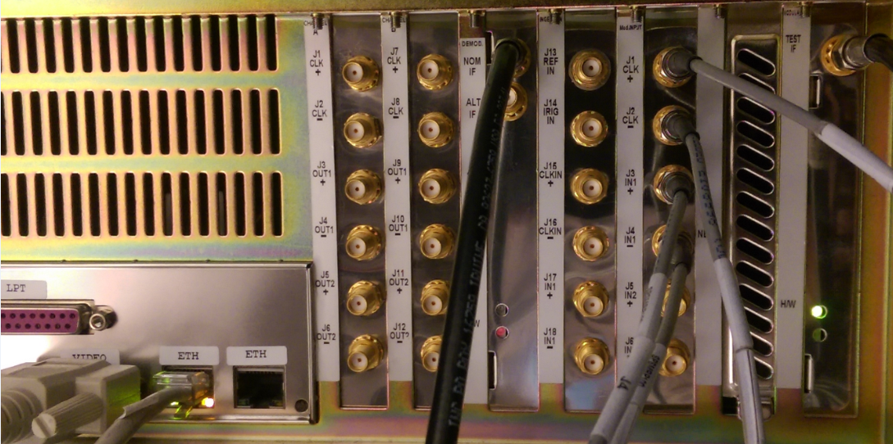

Figure 6‑20 Cortex Series Back Panel

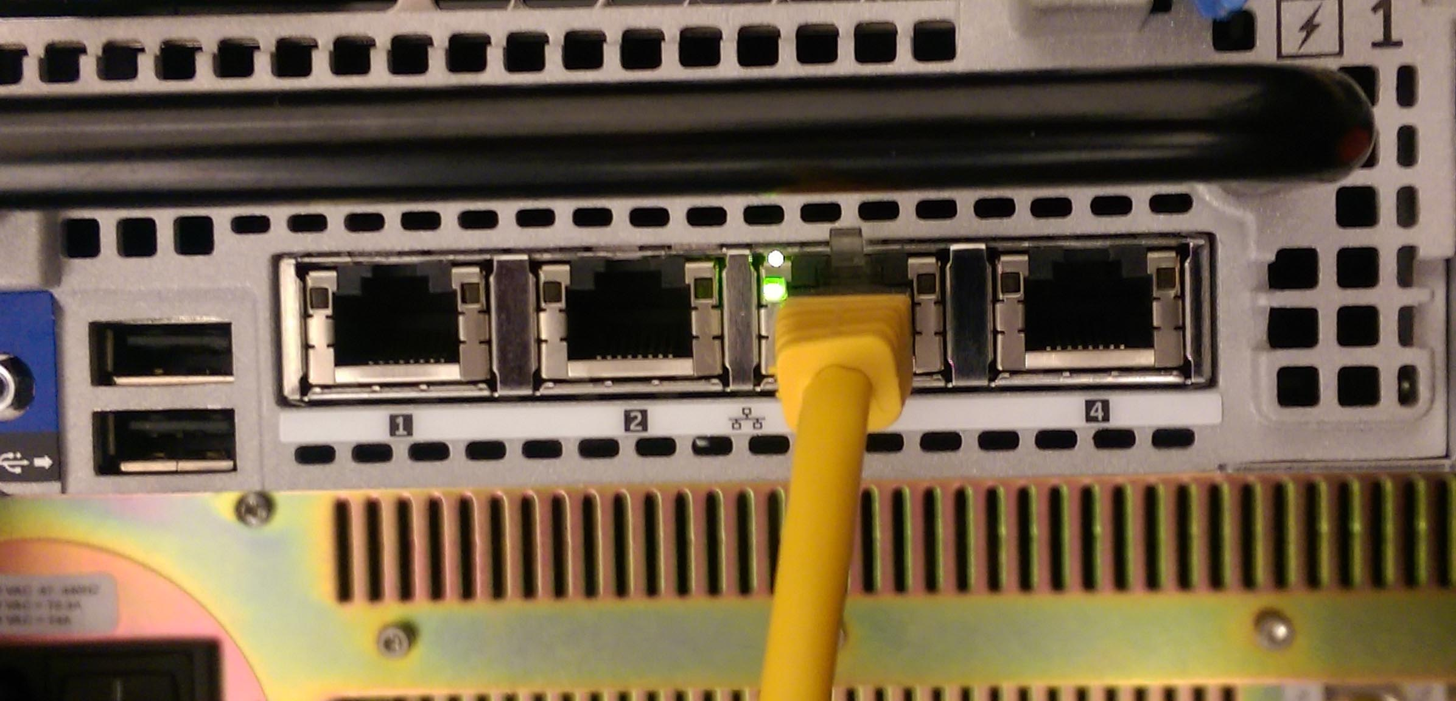

Figure 6‑21 Amergint Technologies SoftFEP Payload Processor Back Panel showing Ethernet connection to test network.

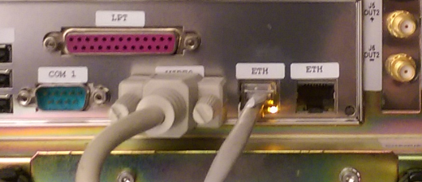

Figure 6‑22 Cortex Series Back Panel showing Ethernet connection to test network.

Figure 6‑21 and Figure 6‑22. shows the Ethernet connection for the Amerigent and Cortex units to the test network.

The procedure to create an Input File for System Testing on the Amergint is as follows:

1. Make sure the desktop computer is powered on that has the Amergint SFEP software.
2. Run the Amerigint software **Low-rate, High-rate FEP 1.0. shown in** Figure 6‑23**.**

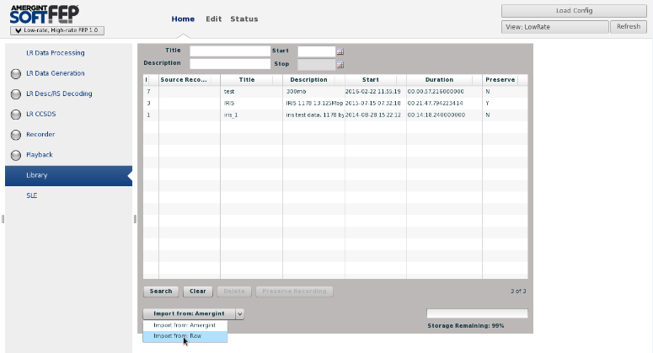

Figure 6‑23 Softfep Gui

1. Select **Import from Raw** from the Import from Amergint tab, Figure 6‑24.

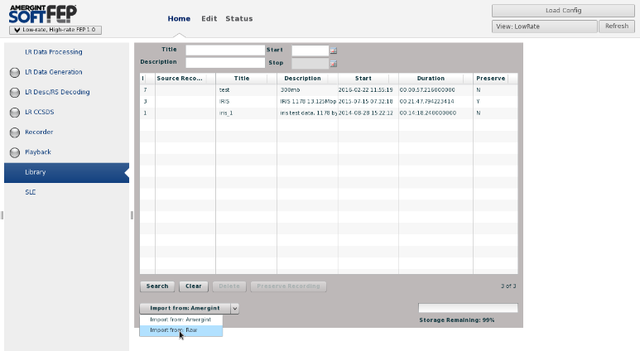

Figure 6‑24 Import from Raw select

1. Click Create Recording once you have created a **Recording Title** and **Recording Description,** Figure 6‑25**.**

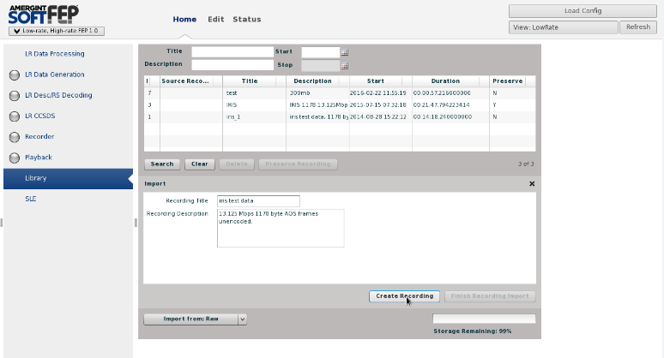

Figure 6‑25 Create Recording and create a **Recording Title** and **Recording Description**

1. Once the recording file is created, highlight the file Figure 6‑26.

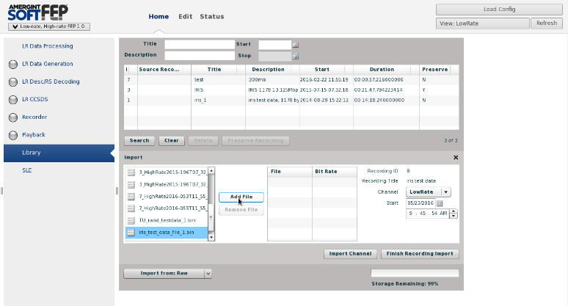

Figure 6‑26 Select recorded file.

1. Select the **Channel** to be HighRate, Figure 6‑27.

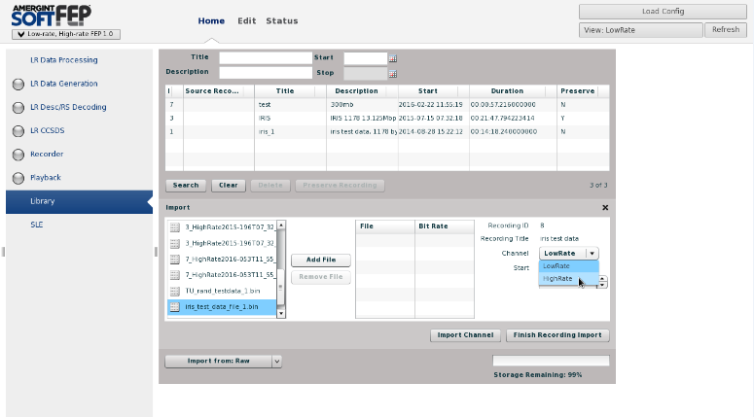

Figure 6‑27 Select the **Channel** to be HighRate.

1. Add file created from the file library Figure 6‑28.

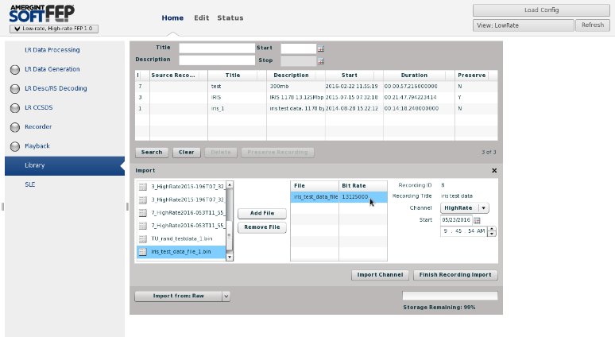

Figure 6‑28 Add file created from the file library

1. Select **Import Channel** Figure 6‑29**.**

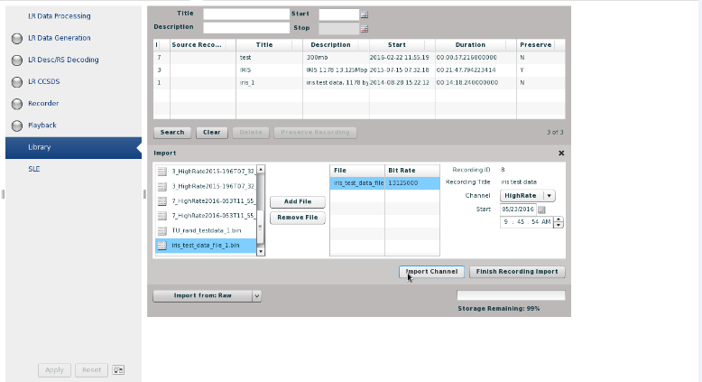

Figure 6‑29 Select **Import Channel**

1. Click **Finish Recording Import** Figure 6‑30**.**

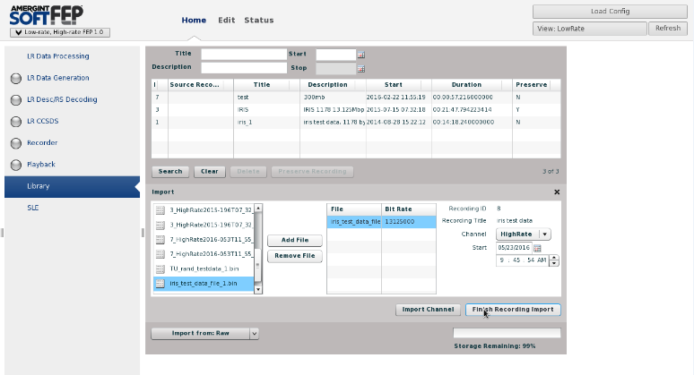

Figure 6‑30 Finish recording import.

1. After completing the nine previous steps, the file just created should appear in the list with all the other files available in the **Playback** environment shown in Figure 6‑31.

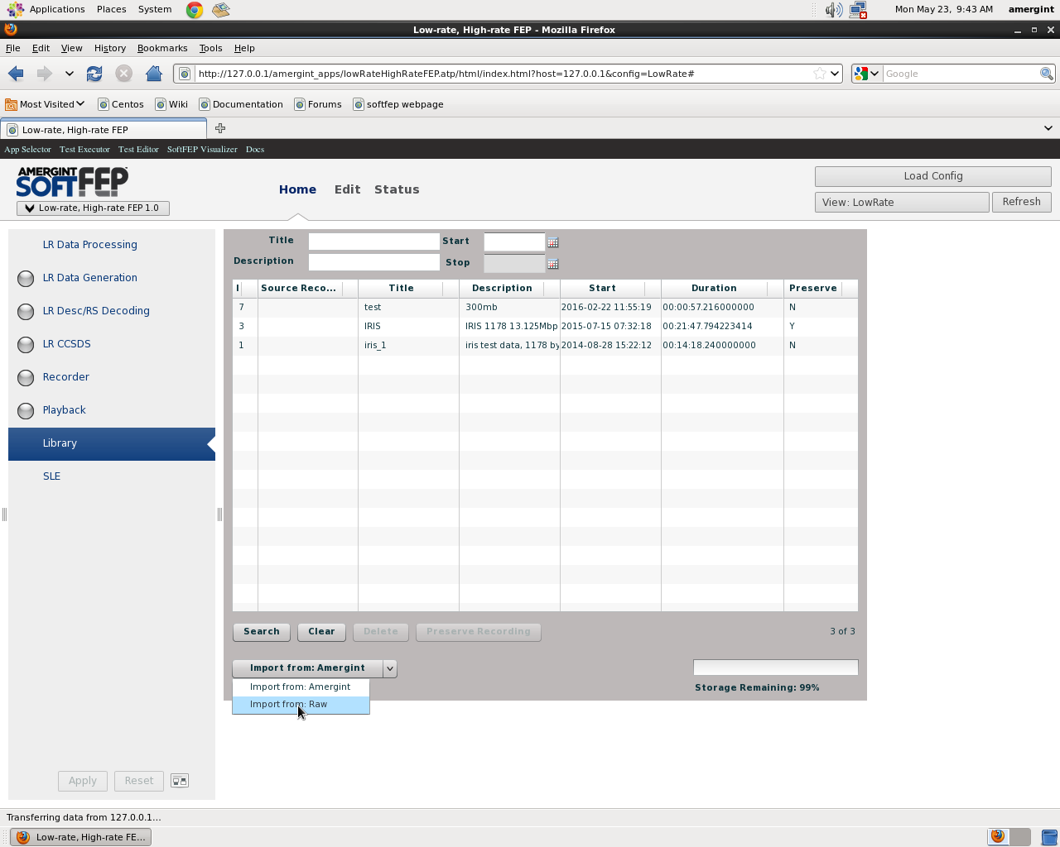

Figure 6‑31 File ready for playback.

The procedure to configure the Cortex for testing follows:

1. Locate the Cortex within the rack and turn on.
2. Select the key in the Monitoring Control Software. Verify that there is a connection to **localhost:1~ see** Figure 6‑32**.**

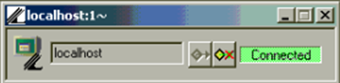

Figure 6‑32 connection to **localhost:1**

1. Test Environment Setup on Cortex Figure 6‑33.
   1. Blue circle: Test Modulator Unit
   2. Red circle: Demodulator Unit
   3. Green circle: Data Processing Unit

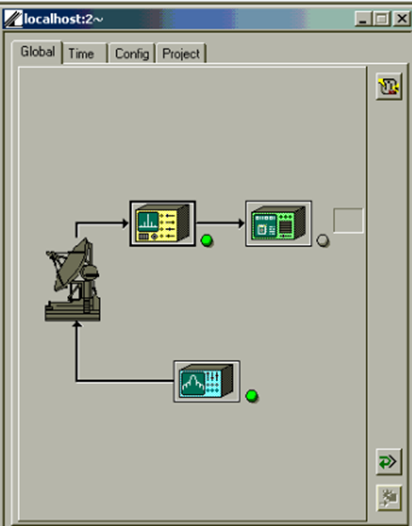

Figure 6‑33 Cortex Setup

1. Select Data Process Unit-A. Make sure all the information as you see it displayed below resembles your entry on the Cortex (Frame tab) see Figure 6‑34.

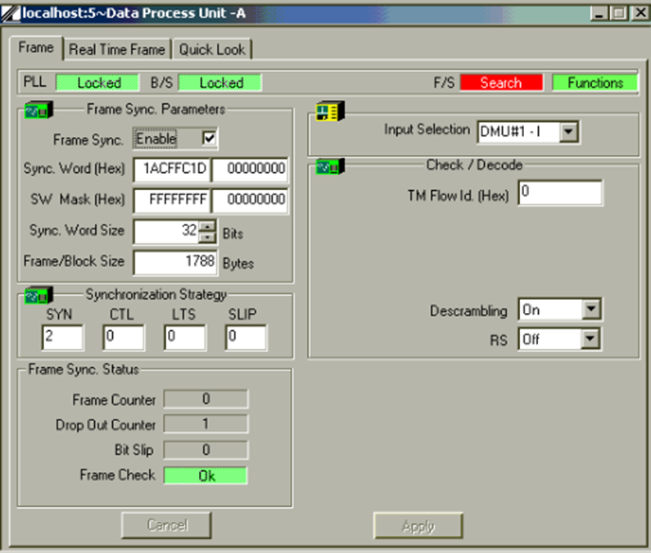

Figure 6‑34 Cortex frame setup

1. Select Data Process Unit-A. Make sure all the information as you see it displayed below resembles your entry on the Cortex (Real Time Frame tab), see Figure 6‑35.

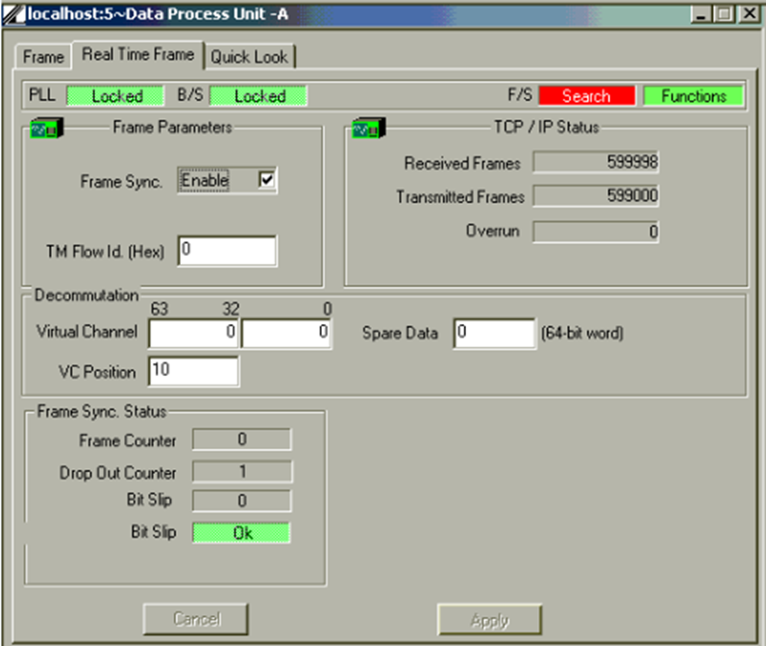

Figure 6‑35 Cortex Real Time frame setup

1. Demodulator Unit 1. Make sure all the information as you see it displayed below resembles your entry on the Cortex (Global tab). See Figure 6‑36.

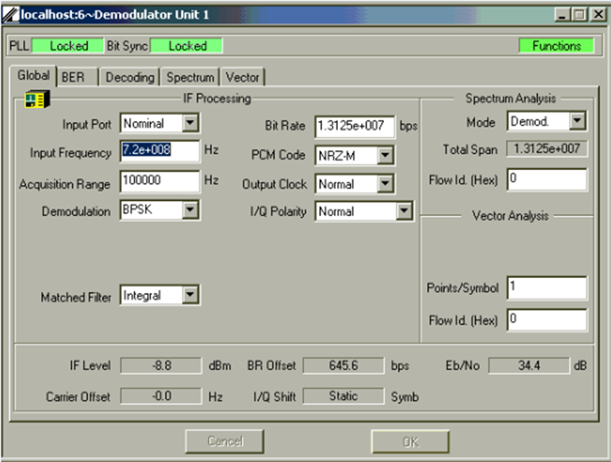

Figure 6‑36 Cortex Global tab setup

1. Demodulator Unit 1. Make sure all the information as you see it displayed below resembles your entry on the Cortex (BER tab). See Figure 6‑37.

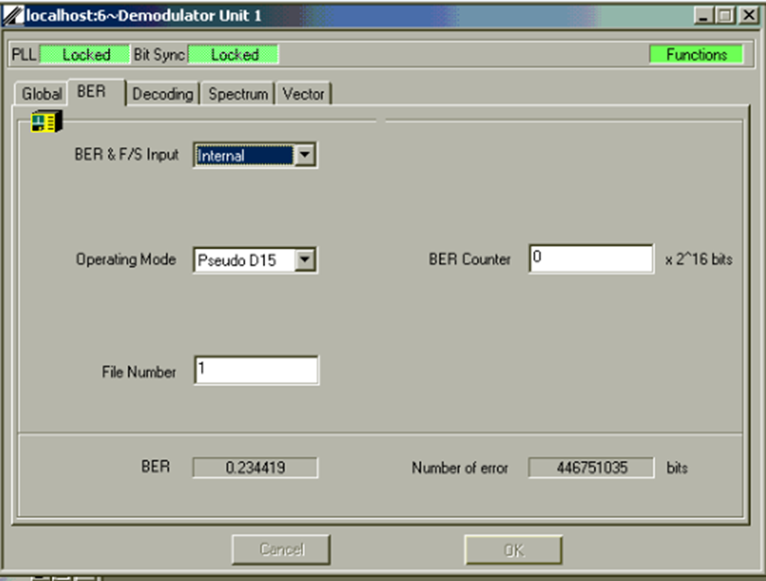

Figure 6‑37 Cortex BER tab setup

1. Demodulator Unit 1. Make sure all the information as you see it displayed below resembles your entry on the Cortex (Decoding tab). Figure 6‑38.

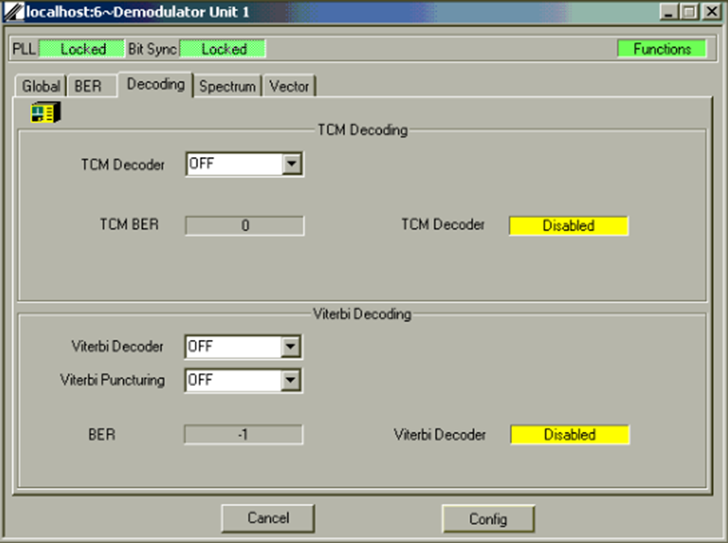

Figure 6‑38 Cortex Decoding tab setup

1. Test Modulator Unit. Make sure all the information as you see it displayed below resembles your entry on the Cortex (Modulation tab Figure 6‑39.

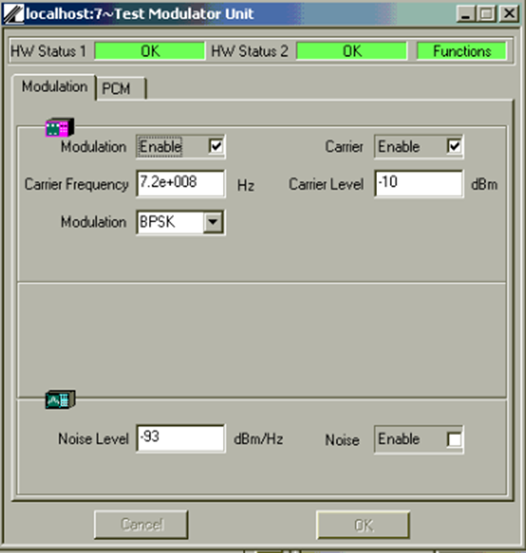

Figure 6‑39 Cortex Modulation tab setup

Test Modulator Unit. Make sure all the information as you see it displayed below resembles your entry on the Cortex (PCM tab), Figure 6‑40.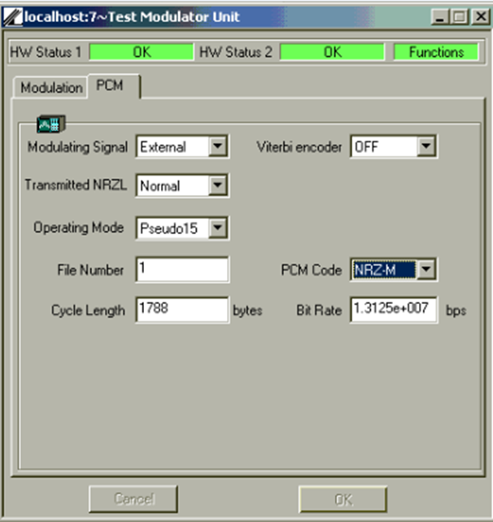

Figure 6‑40 Cortex PCM tab setup

Configuring the Cortex for DAPHNE Testing:

1. Click the key at the bottom of the Cortex screen, Figure 6‑41.

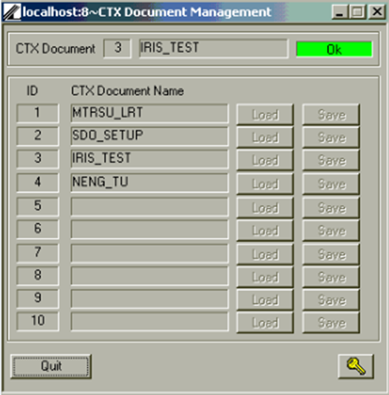

Figure 6‑41 Test configuration window for Cortex

Click the key in the CTX Document Management Window. And then press enter, Figure 6‑42.

1. 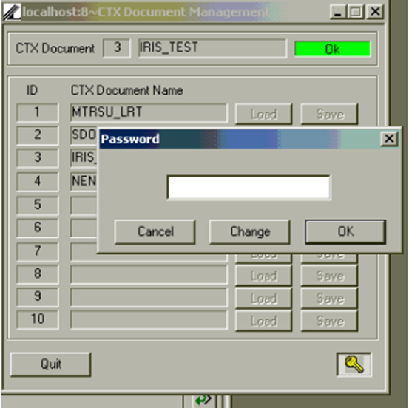

Figure 6‑42 Test configuration window for Cortex (cont)

1. Click the Load Button for ID 3. This will set the configuration for the Cortex. This configuration is used when testing the DAPHNE Units. Figure 6‑43.

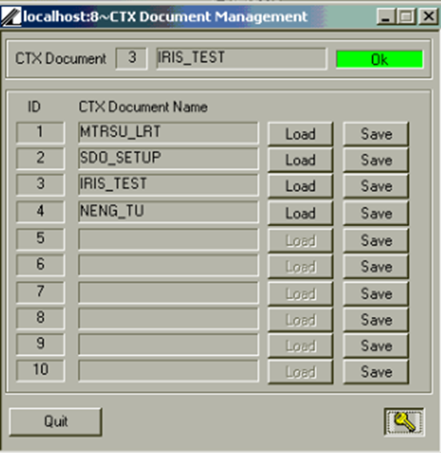

Figure 6‑43 Loading IRIS_TEST configuration

1. Once **IRIS_TEST** has been selected, you can click Quit to exit the window. Your configuration setup is now complete. You will have to do this every time the Cortex is shut off or rebooted Figure 6‑44.



Figure 6‑44 Closing configuration window

**Running the test (LTT or STT)**

Configure the special test control software written by Peter Fetterer, 566 to simulate a series of passes. The software controls all equipment and loops the data file from the Amerigent that feeds the signal generator. A long set of data was taken with 130 passes each 10 minutes long for the primary server and is referred to as the long term test (LTT). A shorter set e.g. 20 passes can be taken for the backup server and is referred to as the short term test (STT).

This software also interfaces to DAPHNE log files to monitor number of output files it creates and frames it handles. The information is stored in log files that are later analyzed. An example is shown in Figure 6‑48.

The test controller GUI is shown in Figure 6‑45 and Figure 6‑46. The Number of Test Iterations setting determines the length of the test.

**Description:**

Run DAPHNE testbed GUI:

1. Open a terminal
2. Log in
3. Assure account used has the appropriate permissions
4. Assure that the needed directory DAPHNE_testbed_GUI is accessible
5. To start the DAPHNE GUI, type: ./Run.sh
6. Once the GUI comes up, before beginning a LTT or STT make sure the Cortex is reset to 0 frames send for transmitter and receiver
7. To begin a STT or LTT click the respective button to do so as it appears on the GUI.
8. Click view at the top of the monitor window screen to open the DAPHNE TLM Dialog box. This keeps a tab of VC2’s, VC3’s, and VC63’s for the test. This monitors also show key DAPHNE status information. See Figure 6‑46.

At the end of the test note the frame counts on the Cortex screen to quantify any remaining frames. See Figure 6‑47.

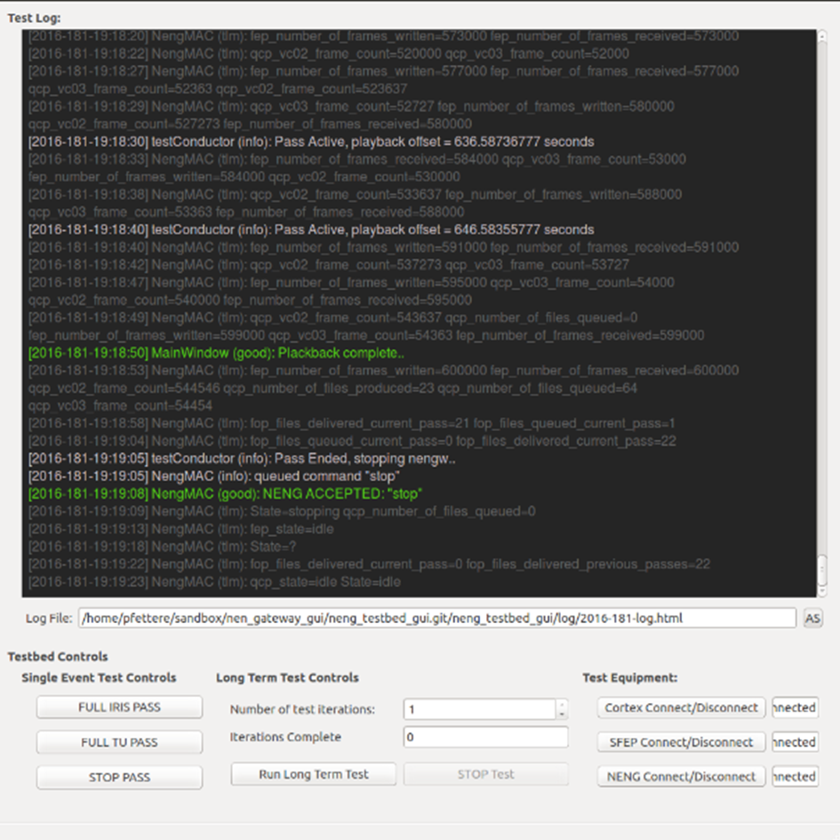

Figure 6‑45 Test Controller GUI test setup

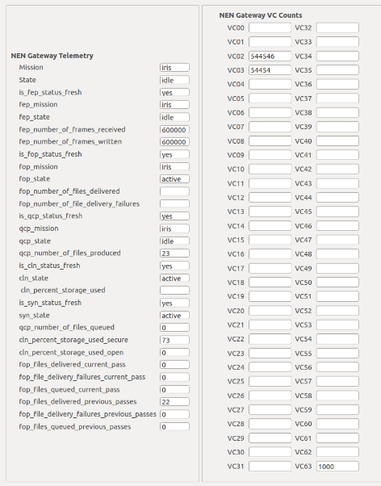

Figure 6‑46 Controller GUI monitor showing VC2 and VC3 counts

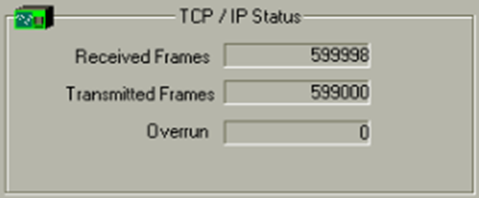

Figure 6‑47 Screenshot of Cortex from 1 IRIS Pass

#### Processing Data

Once the test run is complete the following explains the use of DataChecker/AOSCounterChecker to process the data for frame counts and quality.

**Purpose:**

To analyze the frame count and quality from the test.

Configuration:

See flow chart below, AOSCounterChecker DataCheckerMain Flowchart of how DataChecker.py functions

**Description:**

Run DataChecker.py script:

1. Open a terminal
2. Log in
3. Assure account used has the appropriate permissions
4. Assure that the needed directory DataChecker.py is accessible
5. To run the .py script, type: python DataChecker.py
6. Once an .ldf is present in the ldf directory, the script executes a process of comparing the .qac and .tlm files generated.
7. If the .qac and .tlm files are equal to one another for a particular pass, files transmitted are being received properly.
8. AOSCounterChecker creates logs with the error noted and also counts for VC02 and VC03. See Figure 6‑48 and Figure 6‑49.
9. Process these logs to compare counts with that expected using any tool desired such as excel, matlab, or a self-written script. One simple approach is to concatenate the log files import it to EXCEL and sort the VC channel frame counts.

**AOSCounterChecker DataChecker Main Flowchart**

**Delete all tlm and qac files**

In Directory /rip2moc/tlm

Delete files and log same.

**End Loop**

**Cleanup ldf directory**

Remove files from ldf directory /rip2moc/ldf and log same.

**run aos counter**

1. Run **AosCounterChecker_IRIS 0** for VC2 frames; store results in /rip2moc/log directory as <filename>_VC02.log.
2. Run **AosCounterChecker_IRIS 0** for VC3 frames; store results in /rip2moc/log directory as <filename>_VC03.log.
3. If count equals 1 log counter failure.

**generate VC2 and VC3 tlm counts from ldf file**

1. Remove VC files from /tmp directory and log deletion.
2. Create new VC files in the /rip2moc/tlm directory and log same.
3. If not VC2 / VC3 file log as unknown.

**Make Log Entry**

<filename>[.tlm/.qac] md5sum do not agree (FAILURE)

<filename>[.tlm/.qac] md5sum agree (PASS)

Yes

No

Qac check passed?

**check_md5_qac**

In Directory /rip2moc/tlm

Open <filename>.qac (read only), get MD5 Checksum, Compute MD5 Checksum from <filename>.tlm file, and Compare

**get_pass_files_to_check**

In Directory /rip2moc/ldf

Open <filename>.ldf (read only), strip off leading blank characters and append to previous line

Yes

Sleep 10

No

ldf file in /rip2moc/ldf directory?

**Main Loop**

Look for ldf file in /rip2moc/ldf directory

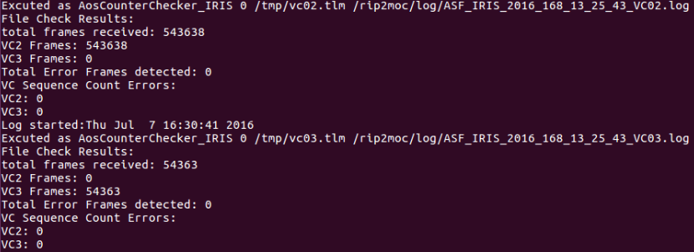

Figure 6‑48 AosCounterChecker script log excerpt showing VC2/VC3 counts and errors for DUT #1 LTT

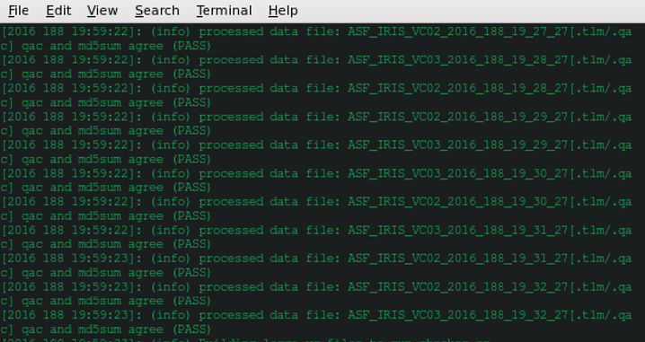

Figure 6‑49 AOSCounterChecker example output for ASF_IRIS_2016_188_19_27_27.ldf, results for .qac and md5sum check for DUT output showing passed Checksum.

### Disk I/O Test:



### Removable Media Test



### Logging Storage/ Memory Overflow Management Test

**Purpose:**

Insure that the DAPHNE will erase log files which are 7 days old to meet the requirement.

**Note:** The software is actually designed to remove the 7 day old files when the system is at 26.01% free.

DUT:  Each Raid memory unit and server combination in a DAPHNE.  Backup servers are not tested with the RAIDs.  This test only applies to secure side memory units.

Configuration:

The test is performed in parallel with the operating DAPHNE system.  A script running from within the native Linux operating system fills up the Raid units with artificially created data files.  Once the memory is full enough to cross the thresholds the DAPHNE subroutines automatically work to delete the oldest files in the background.

The open side memory is controlled through a “synch” software and is tested differently from the secure side. The open side automatically synchronizes with the secure side so overflow is implemented by mirroring the secure side.

Associated Requirements:

This section will show compliance with the following requirement.

DAPHNE-OPS-012.2 Old data removal

**PASS/FAIL criteria:**

The pass criteria is that the removes data older than 7 days on both secure and open side.

The unit fails if it does not remove data older than 7 days.

**Description:**

Run Disk I/O performance Tool:

1. Open a terminal
2. Log in
3. Assure account used has the appropriate permissions
4. Assure that the needed script (fill_disk.py) is accessible
5. Go to the following directory

/data

1. Type:

python fill_disk.py <directory> <block size> <1> <number of files>

Example: fill_disk.py . 1073741824 1 9

This will create 9, 1TB files

For this test we created 5000 files each 10 TB  10737418240

1. This script will generate a set of test files that will fill the disk space by more than 75%.  The script dates the files more than 7 days in the past.
2. Verify that the file dates are 7 days old.
3. Confirm memory is more than 75% full by checking memory status details by typing: ls –l.
4. Wait an hour
5. The system should automatically start deleting the oldest test files until the storage drops to below 75%.
6. Recheck memory status to confirm it is below 75%.
7. Confirm DAPHNE software deletion actions by looking at the DAPHNE log files in the /rip/cln/log directory.
8. Manually delete the remaining dummy files created in step 3 above.
9. To test the open side memory synch function do the following.
10. On the secure side server navigate to a directory that is synched. The /rip/tlm/ “hour” directories are all synched and can be used for this test.
11. Create a test file using any method desired.
12. Wait for a few minutes.
13. On the corresponding open side server navigate to the same directory and do a ls command to confirm the test file was automatically created (was synchronized correctly).
14. From the secure server delete the test file.
15. Wait for a few minutes.
16. On the open side server confirm that the file was also deleted.
17. If the action occurred this would indicate that the synch function is correctly working and the memory overflow function is also working via the secure server.

Table Logging Storage Test

|  |  |
| --- | --- |
| Event | Pass/Fail |
| Files erased |  |

### 

**Purpose:**

Verify compliance with the system latency requirements which are listed below:

**DAPHNE-PERF-001** Local cmd response 5 secs

**DAPHNE-PERF-002** loading configuration 120 secs

**DAPHNE-PERF-003** Activation of return data 60 secs

**DAPHNE-PERF-009** latency shall not exceed 3 minutes

|  |  |
| --- | --- |
| NENG-PERF-001 | DAPHNE shall respond to commands from the remote TCP/IP interface in less than 5 seconds. |
| NENG-PERF-002 | For NENSN supports, operations DAPHNE shall execute setup for operations support within 120 seconds of being commanded. prior to the scheduled start time. |
| NENG-PERF-009 | From ingest to the LAN to the delivery of IP files to the LAN, the latency shall not exceed 3 minutes for nominal operations. |

DUT:  DAPHNE Unit 1 and Unit 2 in both primary and backup operational configurations.

The latency is generically defined as “end time” minus “start time”.

AOSCounterChecker and DAPHNE system log files will be analyzed to identify these times for the latency calculation for each of the four requirements.

|  |
| --- |
| For the Requirement DAPHNE-PERF-001 Local cmd response 5 secs Requirement: DAPHNE-PERF-001 Local cmd response 5 secs: Screen shots of applicable log files and processing scripts will show compliance with this latency requirement.  **PASS/FAIL criteria:**  Local command response < 5 seconds PASS  Local command response ≥ 5 seconds FAIL  **Example from DUT Unit #1**  The screen shot Figure 6‑51 is of the TestController log file that shows time for a command sent and time for a DAPHNE response . The response time is 5 seconds which is calculated by 39 seconds-24 seconds.    Figure 6‑51 TestController log file that shows time for a command sent and time for a DAPHNE response |
| For the requirement DAPHNE-PERF-002 loading configuration 120 secs Requirement: DAPHNE-PERF-002 loading configuration 120 secs: Screen shots of applicable log files and processing scripts will show compliance with this latency requirement.  **PASS/FAIL criteria:**  Configure setup < 120 seconds PASS  Configure setup ≥ 120 seconds FAIL  **Example from DUT Unit #1**  The Test Controller screen shot Figure 6‑52 shows that DAPHNE is both configured and started in well under the required time for just the configuration. The end time is 39 seconds and the start time is 24 seconds in this example which leads to a latency of 15 seconds calculated by 29 seconds-24 seconds. The end time is actually the time the processes starts and includes the configuration.    Figure 6‑52 shows the TestController log file that shows time for a setup command sent and time for a DAPHNE response . |
|  |

#### DAPHNE-PERF-009 latency shall not exceed 3 minutes

**PASS/FAIL criteria:**

Data delivery to LAN latency < 3 minutes PASS

Data delivery to LAN latency ≥ 3 minutes FAIL

The steps to get the start and stop times for this requirement are listed below.

The start time for this requirement is when the data arrives at the DAPHNE and is approximated by the time the .raw files were first processed called the “qcp time”. The error of this approximation has been evaluated at under 1 millisecond and can be ignored. The end time is when the .tlm file is queued to be delivered to the MOC and is referred to as the “fop time”.

**Description:**

1. Open a terminal
2. Login to secure side as rip
3. Change directory to: /rip/fep/log
4. Type: ls –al
5. Look for the largest size file from the list.
6. Write down the file number with .raw extension.
7. Change directory to: /rip/qcp/log
8. Use grep <raw number file without the .raw extension> *.log*
9. Look for a VC02 or VC03 file that has counts in them
10. Change directory to: /rip/fop/log
11. Use grep <filename of VC02 or VC03> *.log*
12. To calculate latency, subtract fop_sent_time – qcp_sent_time.

Example from DUT Unit #1 Primary:

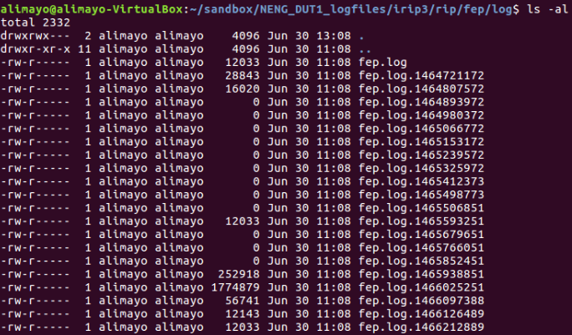

Figure 6‑54 The file of interest is the largest (corresponding to the LTT) fep.log.1466025251.

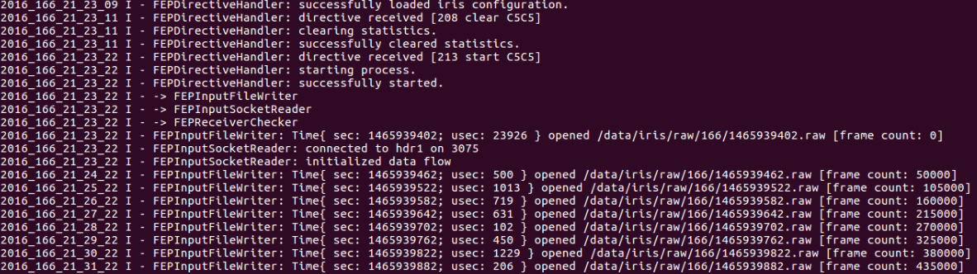

Figure 6‑55 Contents of the largest file. 1465939462.raw is first file with frames.

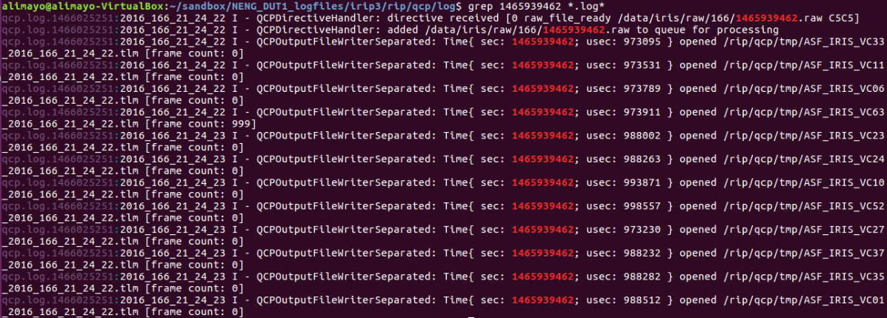

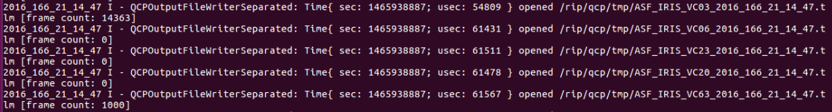

Figure 6‑56 QCP log excerpt showing name of .tlm file created from 1465939462.raw. The VC03 is shown in the continued second panel showing the tlm file created ASF_IRIS_VC03_2016_166_21_14_47.tlm.



Figure 6‑57 Fop log showing sent time of filename: ASF_IRIS_VC03_2016_166_21_14_47.tlm

Latency = fop sent time - qcp_sent time

= [HH_MM_SS] - [HH_MM_SS]

= [21_15_49] – [21_14_47]

= [1_2] or 1 min 2 seconds

### Security Verification

|  |  |
| --- | --- |
| NENG-SEC-001 | DAPHNE shall provide audit trail capability in compliance with NPR 2810.1A, Section 4.2, Audit Trail and Accountability Requirements. |
| NENG-SEC-002 | DAPHNE shall support security functions implemented by NEN Systems in compliance with NPR 2810.1A Security of Information Technology when providing interfaces and communications services to other NEN Systems and customers. |
| NENG-SEC-003 | DAPHNE shall adhere to the security requirements specified in the 700-DOC-029, NASA Integrated Services Network (NISN) Internet Protocol Operational Network (IONet) Security Policy, Section 3 IONet Policies and Security Requirements. |
| NENG-SEC-004 | DAPHNE shall use security controls, including user access and authentication controls, as specified in NIST SP 800-53, Recommended Security Controls for Federal Information Systems and Organizations, Appendix F: Security Control Catalog, High Impact Baseline, and NPR 2810.1A, Security of Information Technology. |
| NENG-SEC-005 | DAPHNE components shall be configured using NASA’s operating system and application configuration benchmarks, as specified in, NIST SP 800-53, Recommended Security Controls for Federal Information Systems and Organizations. |
| NENG-SEC-006 | DAPHNE shall implement authentication for data transfer services invoked by external users. |
| NENG-SEC-007 | DAPHNE shall support identification and authentication of network devices prior to connection |
| NENG-SEC-009 | DAPHNE shall support peer entity authentication structures. |
| NENG-SEC-010 | DAPHNE shall provide access enforcement mechanisms such as Access Control Lists to control access between users and/or processes acting on behalf of users on interconnected systems. |
| NENG-SEC-011 | DAPHNE shall provide a system logging function to log user access and authentication. |
| NENG-SEC-012 | DAPHNE shall provide a system logging function to log configuration modifications. |

## Post Shipment Verification at Ground Station

**Purpose:**

The procedures described in this section will insure that DAPHNE system meets all system requirements, is fully functional and is ready for operations at the NASA Ground Station. In summary the activities will: confirm the station timing standards are fully integrated, demonstrate full operations, assure the system is securely configured correctly, demonstrate “Self Service” file retrieval, and exercise error reporting. The test will be described in separate topic related sections below.

The operational test forms the core of these activities and will be run in real-time configured in parallel with the old DAPHNE system that is to be replaced. Both systems will be input with real-time mission data demodulated by a NEN receiver. This test is crucial in determining the operability of the system, and any issues encountered need to be recorded and shared with both the operations and development teams.

After the system is fully verified the process to reconfigure the system for operations is detailed.

DUT:  DAPHNE.

Configuration:

Each DAPHNE will be setup as it will be for operations; but also in parallel with the old DAPHNE unit being replaced; see Figure 6‑58. The scenarios run for each type of test will be described in each section below.

The M&C will configure and start both old and new DAPHNE units for a mission overpass. Each DAPHNE receives actual telemetry data from a Cortex HDR IF receiver. The data is in AOS frames sent via TCP/IP as it would during normal operations. The DUT processes the data, and automatically send it to the MOC via the operational NISN telecommunication network.

The parallel test itself is similar to the functional and quality tests from section 6.1.1.1, however the data source, post-test data processing, and delivery point will be different. Verification information will be gathered from DAPHNE, M&C and MOC.

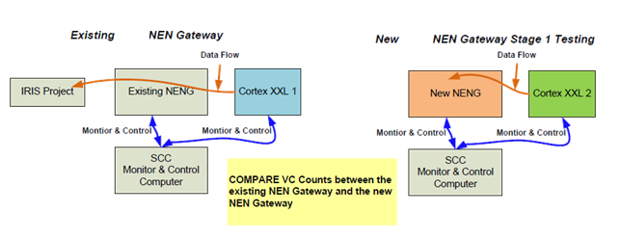

Figure 6‑58 DAPHNE Parallel Test Pass Summary Report (M&C)

### Standards Test

This section will verify compliance with the requirements listed below that have to do with connection to and use of the sites timing standard.

**Requirement:**

DAPHNE-STD-002 Time & Frequency input

DAPHNE-STD-006 NEN subsystem timing interface.

DAPHNE-STD-007 Receive sNTP

Configuration:

The same setup as for parallel operations, described above, is used, but no satellite over-pass is necessary.

Pass/Fail Criteria: Pass if the ntp is indicated.

**Procedure:**

Show NTP is installed and operating in DAPHNE and synced to station time.

1. Open terminal and Type:
2. ntpq –p
3. date
4. Log result in Table 7.

Table 7 Standard Requirement Verifcation

|  |  |  |
| --- | --- | --- |
| Requirement to Verify | Pass/Fail |  |
| DAPHNE-STD-002 Time & Frequency input |  |  |
| DAPHNE-STD-006 NEN subsystem timing interface |  |  |
| DAPHNE-STD-007 Receive sNTP |  |  |
|  |  |  |

### Parallel Operational Testing

#### Basic Functionality and Data Quality

This section will demonstrate basic functionality and data quality of the system by comparing delivered VC counts between the old and new system.



**Configuration:**  The parallel configuration previously described.Numerous passes should be run for this test. The exact number can be determined by the operations team.

A number of combinations of new and original DAPHNEs will be run to confirm full capability.

Primary configurations are tested over multiple overpasses. The number of overpasses is determined by the operational and development teams. Backup configurations can be tested at the discretion of the operational team. Backup testing requires reconfiguration as described in section 6.1.1.4 by changing the Raids IP address and physically moving the four fiber optic cables from the primary server to the backup server.

Note: The custom test control or Datachecker software mentioned in 6.1.1.1 is not used to run these tests or process the data.

**Overpass Procedure Description:**

1. Wait for IRIS pass.
   1. Note Julian time (UTC) when the first frame hits the DAPHNE.
2. Run the two parallel DAPHNE units.
3. Wait for pass and processing to finish. The process should take approximately 10 minutes from start to finish.
4. Pull a copy of the all DAPHNE Logs for post pass analysis for the pass in question from both existing DAPHNE and the under test DAPHNE systems.
   1. Figure 6‑59 shows a sample Log file for both systems DAPHNE (Operational system) and the DAPHNE Backup (System under test).
   2. This file is located on the M&C computer under (C:\hwcntrl WGS\pass status\*.txt)
      1. Follow M&C proper procedure for copying the file (Windows copy)
5. On both the existing DAPHNE and the DAPHNE under test record the following information into Table 7, from the M&C log for each DUT and over-pass, see example shown in Figure 6‑59:
   1. the number of frames received into the DAPHNE (by Virtual Channel)
   2. the number of files produced
   3. the number of files delivered
6. Obtain VC counts from the MOC for comparison to the M&C report numbers.
7. Repeat 1 through 6 for additional overpasses.
8. Repeat 1 through 7 for additional DAPHNE combinations and configurations.

**Pass/Fail Criteria:** For the test to be considered as a pass, both the Operational DAPHNE and DAPHNE under test numbers should match 1:1 for the 6 check points listed in Table 7. If counts from the MOC are available they should also match the other two.

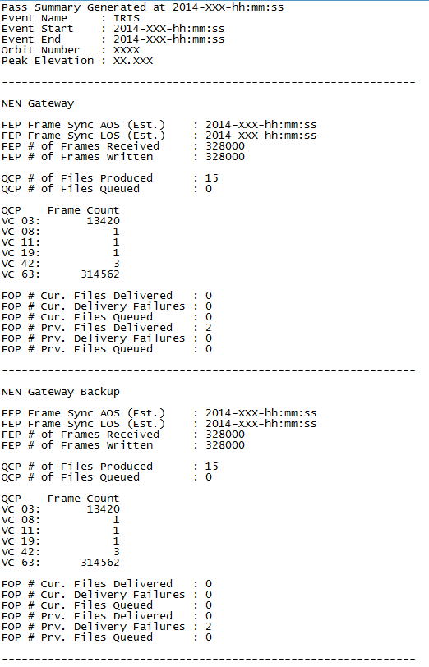

Figure 6‑59 Example DAPHNE Sample M&C Log File

**Results:**

Table Parallel Test check points

|  |  |  |  |  |  |
| --- | --- | --- | --- | --- | --- |
| Check Point | Orig DAPHNE at M&C | New DAPHNE at M&C | Orig. at MOC | New at MOC | Pass/Fail |
| FEP # of Frames received |  |  |  |  |  |
| QCP # of VC2 received |  |  |  |  |  |
| QCP # of VC3 received |  |  |  |  |  |
| QCP # of VC63 received |  |  |  |  |  |
| QCP # of files produced |  |  |  |  |  |
| FOP # of files delivered |  |  |  |  |  |
|  |  |  |  |  |  |
|  |  |  |  |  |  |

**Interface performance:**

To successful complete the basic functional test the system interfaces must operate. A successful test inherently confirms the basic interface performance. Though, there are no specific interface requirements to verify, this test supports the basic functionality demonstrated in Table 8. Complete this table for each configuration tested and insert it in the test report.

Table 9 Interface Performance

|  |  |  |  |
| --- | --- | --- | --- |
| Interface | Comment/Notes/Performance | DUT | Pass/Fail |
| Cortex-XXL Interface | DAPHNE system connects and pulls data as expected, conformant to Cortex XXL ICD documentation. |  |  |
| M&C interface | NEN M&C software is able to command and control the DAPHNE and shows compatibility with current system and conformance with DAPHNE <-> NEN MOC ICD |  |  |
| IRIS MOC Interface | New DAPHNE hardware is able to deliver file to IRIS MOC via SSH protocol. |  |  |

#### Specific Operational and Performance Requirement Verification

In addition to confirming basic functionality and data quality the parallel test will also verify compliance with a number of specific operational and performance requirements. These requirements, listed below, were previously verified during pre-shipment testing under section 6.1.1, and 6.1.5. The items are also listed in the Requirements Verification Table in the Appendix, see the column labeled “6.2”.

The pass/fail criteria and the procedures to verify the requirements are given in 6.1.1.2 and 6.1.5. The details will not be repeated here. Please note that the data source and delivery point for the data are different compared to the earlier testing. The M&C GUI is a new resource that can be used to help re-verify the requirement, see Figure 6‑60. This tool was not available for the earlier testing. These requirements should also be confirmed by the MOC through their analysis of the data. The custom test control or Datachecker software is not used to run these tests or process the data.

Figure 6‑60 Example DAPHNE M&C GUI

Table 9 should be completed for each DUT and inserted into the test report. Supporting log files excerpts should be included in the test report.

Table 10 Operational Requirements to Re-verify from 6.1.1.2

|  |  |  |
| --- | --- | --- |
| Requirement to re-verify | Pass/Fall |  |
| DAPHNE-OPS-001 automated data delivery |  |  |
| DAPHNE-OPS-002 Attempt data delivery once |  |  |
| DAPHNE-OPS-004 Unattended nominal operation |  |  |
| DAPHNE-OPS-007 autonomous operation |  |  |
| DAPHNE-OPS-010 Data transport to repository |  |  |
| DAPHNE-OPS-012 Secure to Open storage |  |  |
| DAPHNE-OPS-013 Storage system status |  |  |
| DAPHNE-OPS-013.1 Statistics provided by DAPHNE storage system shall include, but not be limited to: total storage available for secure/open, total storage used for secure/open, disk health for secure/open, storage system health. |  |  |
| DAPHNE-OPS-014 DAPHNE shall provide status via a TCP/IP stream for remote monitoring. |  |  |
| DAPHNE-OPS-015 Remote configurable |  |  |
| DAPHNE-OPS-016 System logs and failure logs |  |  |
| DAPHNE-OPS-018 DAPHNE shall provide alerts to notify Operators of configuration changes. |  |  |
| DAPHNE-OPS-019 Operate in office/computer room |  |  |
| DAPHNE-PERF-006 Min Receive and process data rate 13.125 Mbps |  |  |
| DAPHNE-ServAssure-004 Log of file delivery attempt |  |  |

The performance requirements to re-verify are listed in Table 11. One test scenario for each DUT is considered sufficient for these requirements. Complete the table and include in the test report with supporting logs excerpts. Figure 6‑61 and Table 12 shows four segments from different DAPHNE log files to use to re-verify the performance requirements.

Table 11 Performance Requirements to Re-verify from 6.1.5

|  |  |  |
| --- | --- | --- |
| Requirements to Re-verify | Pass/Fail |  |
| DAPHNE-PERF-001 Local cmd response 5 secs |  |  |
| DAPHNE-PERF-002 loading configuration 120 secs |  |  |
| DAPHNE-PERF-003 Activation of return data 60 secs |  |  |
| DAPHNE-PERF-009 latency shall not exceed 3 minutes |  |  |

Table Log files to use for re-verification

|  |  |
| --- | --- |
| Requirement Number | Log segment showing conformance |
| DAPHNE-PERF-001 | /rip/ctl/log/<file name .log> |
| DAPHNE-PERF-002 | /rip/ctl/log/<file name .log> |
| DAPHNE-PERF-003 | /rip/fep/log/<file name .log> |
| DAPHNE-PERF-009 | /rip/fop/log/<file name .log> |

|  |
| --- |
|  |
| (a) |
|  |
| (b) |
|  |
| (c) |
|  |
| (d) |

Figure 6‑61 Key Log segments examples (a) & (b) from CTL log file, (c) from FEP Log file, and (d) from FOP Log file

### Self Service Functionality

Purpose: Demonstrate that the IRIS MOC is able to connect to open server and pull files from a previous pass using the Self Service mode.

Pass/Fail Criteria: The unit passes if the MOC can “pull” files from the system. It fails if the MOC cannot pull files.

Configuration:

The same setup as for the parallel operation test is used but the test is performed after at least one over-pass is complete.

Procedure:

1. Assure that an over-pass operation is completed.
2. Request MOC to pull file using the Self-Service mode.
3. MOC to confirm file is received correctly.
4. Complete Table 13 for each DUT.

Table 13 Self Service Mode Verification

|  |  |  |
| --- | --- | --- |
| Item to Verify | Pass/Fail |  |
| Self-Service Mode |  |  |
|  |  |  |
|  |  |  |

### Security Configuration Verification Test:

**Purpose:**

Look at various software configurations on the system and verify that they are set to the values required to conform to the system requirements. The requirements are given below by related sets. Procedures for each set of related requirements are given below with the associated requirements. The requirements are verified by inspecting various system configuration and log files.

Pass/Fail Criteria: The general pass criteria is that the system demonstrates the required security posture. The DUT fails if it does not demonstrate the required security posture.

|  |  |
| --- | --- |
| NENG-SEC-001 | DAPHNE shall provide audit trail capability in compliance with NPR 2810.1A, Section 4.2, Audit Trail and Accountability Requirements. |
| NENG-SEC-002 | DAPHNE shall support security functions implemented by NEN Systems in compliance with NPR 2810.1A Security of Information Technology when providing interfaces and communications services to other NEN Systems and customers. |
| NENG-SEC-003 | DAPHNE shall adhere to the security requirements specified in the 700-DOC-029, NASA Integrated Services Network (NISN) Internet Protocol Operational Network (IONet) Security Policy, Section 3 IONet Policies and Security Requirements. |
| NENG-SEC-004 | DAPHNE shall use security controls, including user access and authentication controls, as specified in NIST SP 800-53, Recommended Security Controls for Federal Information Systems and Organizations, Appendix F: Security Control Catalog, High Impact Baseline, and NPR 2810.1A, Security of Information Technology. |
| NENG-SEC-005 | DAPHNE components shall be configured using NASA’s operating system and application configuration benchmarks, as specified in, NIST SP 800-53, Recommended Security Controls for Federal Information Systems and Organizations. |
| NENG-SEC-006 | DAPHNE shall implement authentication for data transfer services invoked by external users. |
| NENG-SEC-007 | DAPHNE shall support identification and authentication of network devices prior to connection |
| NENG-SEC-009 | DAPHNE shall support peer entity authentication structures. |
| NENG-SEC-010 | DAPHNE shall provide access enforcement mechanisms such as Access Control Lists to control access between users and/or processes acting on behalf of users on interconnected systems. |
| NENG-SEC-011 | DAPHNE shall provide a system logging function to log user access and authentication. |
| NENG-SEC-012 | DAPHNE shall provide a system logging function to log configuration modifications. |

**Requirements**:

DAPHNE-SEC-001 Audit Trail NPR 2810.1A

DAPHNE-SEC-002 support security functions

DAPHNE-SEC-003 Adherence to CSO requirements

DAPHNE-SEC-004 User access and authentication control

DAPHNE-SEC-011 Log user access and authentication

**Procedure:**

Verify that login and sudo/su

1. Type: sudo tail /var/log/auth.log
2. date

**Requirement:**

DAPHNE-SEC-012 Log configuration modifications

**Procedure:**

Verify that service messages are logged to /var/log/messages or their own service logs.

1. Type:
2. cd /var/log
3. sudo /etc/init.d/ntp restart
4. sudo tail –n 25 /var/log/syslog

**Requirements:**

DAPHNE-OPS-012.1 Secure file system

DAPHNE-SEC-007 Identification and authentication

DAPHNE-SEC-010 Access enforcement

**Procedure:**

Show that SSHD is configured to only allow SSHv2 and there is a login banner displayed. (Shown in Figure 6‑62)

* + - 1. The operator should ssh to the DAPHNE system
      2. Type:
      3. ssh [scanuser@XXX.XXX.XXX.XXX](mailto:scanuser@XXX.XXX.XXX.XXX)
      4. where: XXX.XXX.XXX.XXX refers to the IP address

Figure 6‑62 DAPHNE Banner

**Requirement:**

DAPHNE-SEC-013 Limited active ports and protocols

**Procedure:**

Verify limited active ports and protocols

1. Open terminal and Type:
2. sudo netstat –nlptu | grep LISTEN
3. date

**Requirement:**

DAPHNE-SEC-014 static IP addresses

**Procedure:**

Verify static IP

1. while logged to IRIP Type:
2. cat /etc/network/interfaces
3. date
4. Note: Look for (iface em1 inet static and iface em2 inet static), if present pass the test.

Table 14 Configuration Verification Table

| Requirement Summary | Pass/Fall |
| --- | --- |
| DAPHNE-SEC-001 Audit Trail NPR 2810.1A |  |
| DAPHNE-SEC-002 support security functions |  |
| DAPHNE-SEC-003 Adherence to CSO requirements |  |
| DAPHNE-SEC-004 User access and authentication control |  |
| DAPHNE-SEC-011 Log user access and authentication |  |
| DAPHNE-SEC-012 Log configuration modifications |  |
| DAPHNE-OPS-012.1 Secure file system |  |
| DAPHNE-SEC-007 Identification and authentication |  |
| DAPHNE-SEC-010 Access enforcement |  |
| DAPHNE-STD-002 Time & Frequency input |  |
| DAPHNE-SEC-013 Limited active ports and protocols |  |
| DAPHNE-SEC-014 static IP addresses |  |



### System Failure Mode Test

**Purpose:**

To verify that the systems meets the requirements stated below. To verify that the DAPHNE system performs a self-check and reports only warnings and erroneous conditions to the M&C see red warning in Figure 6‑63 .

**Requirements:**

DAPHNE-OPS-005 Negative reporting

DAPHNE-OPS-006 Self diagnosis

DAPHNE-ServAssure-003 no connection to MOC

**Images and/ or Drawings:**

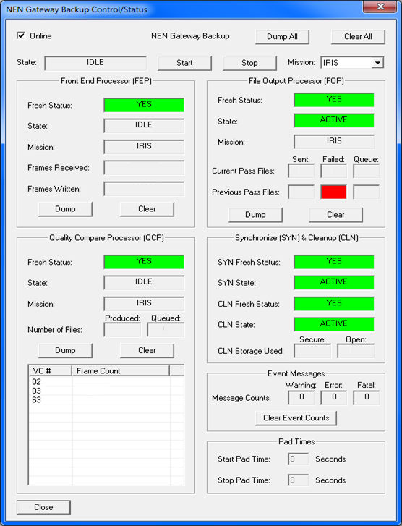

Figure 6‑63 DAPHNE M&C GUI with a failure

**Procedure Description:**

1. This is tested as an add-on scenario to the parallel testing explained earlier in section 6.2.1.
2. The “DAPHNE under test” file output path needs to be changed to dump the received (from Cortex-XXL) data locally on its internal drive. (This in effect cuts the network path to the MOC)
3. Wait for a pass operation to happen
4. After the pass is done, the M&C GUI should report an issue in Red as shown in Figure 6‑63.
5. Check log to confirm that data was stored on the system despite the failure.
6. Complete

**Result:**

A red indicator should be produce in this erroneous condition and is the pass criteria for the two requirements: DAPHNE-OPS-005 Negative reporting, and DAPHNE-OPS-006 Self diagnosis.

The pass criteria for the requirement, DAPHNE-ServAssure-003 no connection to MOC, is that data files are stored despite the loss of a telecommunication path to the MOC.

Table 14 System Failure Mode Verification

|  |  |
| --- | --- |
| Event | Pass/Fail |
| DAPHNE-OPS-005 Negative reporting |  |
| DAPHNE-OPS-006 Self diagnosis |  |
| DAPHNE-ServAssure-003 no connection to MOC |  |

## Pre-Ops Checkout:

**Purpose:**

Switching from parallel to operational configurations requires network configuration changes to the system which need to be implemented and confirmed. The checks listed below confirms that the DAPHNE system network parameters are configured correctly and the system is ready for operations.

**Images and/ or Drawings:**

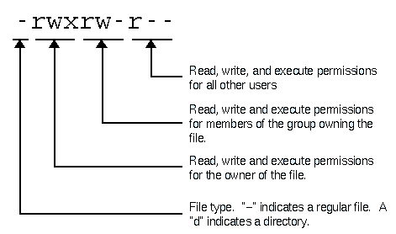

Figure 6‑64 File permission

**Procedure Description: Line items to check**

1. Verify IP connectivity with Cortex XXL.
   1. Type:

ping hdr1

ping hdr2

1. Verify IP connectivity with M&C.
2. Verify IP connectivity with IRIS MOC.
3. Verify SSH login capabilities to IRIS MOC file server. (SSH Keys)
4. Verify IRIS MOC open server access. (SSH Keys, Host keys need updating with IRIS)
5. Verify RIP Secure Side and RIP Open Side connectivity.
6. Verify Directory Permissions for IRIS files on Open Server.
   1. Connect to ORIP (ssh orip ip)
   2. switch to data directory (cd data)
   3. type:

ls –al iris

ls –al iris/ldf/001

ls –al iris/tlm/001

date

Note: Make sure that the permission for the files is (-rwxr-x---). Figure 6‑64 illustrates the meaning of each section of the file permission

**Results:**

**Confirm that each line above is checked and fill out** Table 14 **and insert into the test report.**

Table Pre-Ops Checkout Table

|  |  |
| --- | --- |
| Line Item | Confirmed |
| 1 IP connectivity with Cortex XXL |  |
| 2 IP connectivity with M&C |  |
| 3 IP connectivity with IRIS MOC |  |
| 4 SSH login capabilities to IRIS MOC file server |  |
| 5 IRIS MOC open server access |  |
| 6 RIP Secure Side and RIP Open Side connectivity |  |
| 7 Directory Permissions for IRIS files on Open Server |  |

| ID | DSRR Requirement | Verification | 6.11 | 6.12 | 6.13 | 6.14 | 6.15 | 6.16 | 6.2 |
| --- | --- | --- | --- | --- | --- | --- | --- | --- | --- |
| NENG-OPS-001 | DAPHNE shall provide automated delivery of user data to authorized users. | T | x |  |  |  |  |  |  |
| NENG-OPS-002 | DAPHNE shall attempt automated delivery once. | T | x |  |  |  |  |  |  |
| NENG-OPS-004 | DAPHNE shall operate unattended. | T | x |  |  |  |  |  |  |
| NENG-OPS-005 | DAPHNE shall report warning and erroneous conditions to the operator interface. | T |  |  |  |  |  |  |  |
| NENG-OPS-013 | DAPHNE shall provide system status. | T | x |  |  |  |  |  |  |
| NENG-OPS-013.1 | DAPHNE storage system shall report: the total storage available secure/open, total storage used secure/open, disk health for secure/open, and storage system health. | T | x |  |  |  |  |  |  |
| NENG-OPS-015 | DAPHNE shall be remotely configurable via a TCP/IP. | T | x |  |  |  |  |  |  |
| NENG-OPS-016 | DAPHNE shall provide a system logging function to log system failure and operational activity. | T | x |  |  |  |  |  |  |
| NENG-OPS-019 | DAPHNE storage system shall operate in a NEN computer room environment. | I | x |  |  |  |  |  |  |
| NENG-OPS-020 | DAPHNE shall store at least 28 TBytes of combined Mission data. | I |  |  |  |  |  |  |  |
| NENG-OPS-021 | The DAPHNE storage system shall be a single fault tolerant | I |  |  |  |  |  |  |  |
| NENG-OPS-022 | DAPHNE shall host an access controlled file system. | I |  |  |  |  |  |  |  |
| NENG-OPS-024 | DAPHNE shall provide status via a TCP/IP for remote monitoring. | T | x |  |  |  |  |  |  |
| New | DAPHNE shall send user data in priority order during Automatic Delivery. | t | x |  |  |  |  |  |  |
| NENG-PERF-001 | DAPHNE shall respond to commands from the remote TCP/IP interface in less than 5 seconds. | T |  |  |  |  | x |  |  |
| NENG-PERF-002 | For NENSN supports, operations DAPHNE shall execute setup for operations support within 120 seconds of being commanded. prior to the scheduled start time. | T |  |  |  |  | x |  |  |
| NENG-PERF-009 | From ingest to the LAN to the delivery of IP files to the LAN, the latency shall not exceed 3 minutes for nominal operations. | T |  |  |  |  | x |  |  |
| NENG-PERF-010 | DAPHNE shall receive and process two streams of telemetry data at a rate up to 2 Gbps each | T | x |  |  |  |  |  |  |
| NENG-RMA-005 | DAPHNE shall have an availability of 0.99 for scheduled support periods. | A |  |  |  |  |  |  |  |
| NENG-RMA-015 | DAPHNE's Mean Time To Restore Full Function (MTTRFF) after a first fault shall be less than or equal to 48 hours not including any shipping time. | A |  |  |  |  |  |  |  |
| NENG-SEC-001 | DAPHNE shall provide audit trail capability in compliance with NPR 2810.1A, Section 4.2, Audit Trail and Accountability Requirements. | I |  |  |  |  |  | x |  |
| NENG-SEC-002 | DAPHNE shall support security functions implemented by NEN Systems in compliance with NPR 2810.1A Security of Information Technology when providing interfaces and communications services to other NEN Systems and customers. | I |  |  |  |  |  | x |  |
| NENG-SEC-003 | DAPHNE shall adhere to the security requirements specified in the 700-DOC-029, NASA Integrated Services Network (NISN) Internet Protocol Operational Network (IONet) Security Policy, Section 3 IONet Policies and Security Requirements. | I |  |  |  |  |  | x |  |
| NENG-SEC-004 | DAPHNE shall use security controls, including user access and authentication controls, as specified in NIST SP 800-53, Recommended Security Controls for Federal Information Systems and Organizations, Appendix F: Security Control Catalog, High Impact Baseline, and NPR 2810.1A, Security of Information Technology. | I |  |  |  |  |  | x |  |
| NENG-SEC-005 | DAPHNE components shall be configured using NASA’s operating system and application configuration benchmarks, as specified in, NIST SP 800-53, Recommended Security Controls for Federal Information Systems and Organizations. | I |  |  |  |  |  | x |  |
| NENG-SEC-006 | DAPHNE shall implement authentication for data transfer services invoked by external users. | T |  |  |  |  |  | x |  |
| NENG-SEC-007 | DAPHNE shall support identification and authentication of network devices prior to connection | T |  |  |  |  |  | x |  |
| NENG-SEC-009 | DAPHNE shall support peer entity authentication structures. | T |  |  |  |  |  | x |  |
| NENG-SEC-010 | DAPHNE shall provide access enforcement mechanisms such as Access Control Lists to control access between users and/or processes acting on behalf of users on interconnected systems. | T |  |  |  |  |  | x |  |
| NENG-SEC-011 | DAPHNE shall provide a system logging function to log user access and authentication. | T |  |  |  |  |  | x |  |
| NENG-SEC-012 | DAPHNE shall provide a system logging function to log configuration modifications. | T |  |  |  |  |  | x |  |
| NENG-ServAssure-003 | DAPHNE shall continue to process return data as usual and record it for future delivery self-service in the event that a delivery connection to the MOC is not established. | T |  |  |  |  |  | x |  |
| NENG-ServAssure-004 | DAPHNE shall account for each file delivery attempt. | T | x |  |  |  |  |  |  |
| NENG-ServAssure-005 | DAPHNE shall automatically handle failover from prime system to the backup system in the event of a primary system failure | T |  |  |  |  |  |  |  |
| NENG-ServAssure-006 | DAPHNE shall notify the operator in the event of an auto failover occurred | T |  |  |  |  |  |  |  |
| NENG-ServAssure-007 | DAPHNE shall support emergency interrupts i.e. be reconfigurable at any time, even during an active event. | T |  |  |  |  |  |  |  |
| NENG-STD-002 | DAPHNE shall use the NEN Time and Frequency Subsystem for all NEN DAPHNE functions that require time and frequency referencing. | I |  |  |  |  |  |  | x |
| NENG-STD-004 | DAPHNE shall use Coordinated Universal Time (UTC) for all parameters containing a time value. | I |  |  |  |  |  |  | x |
| NENG-STD-006 | DAPHNE shall interface with the NEN Timing Subsystem to maintain internal time traceable to Coordinated Universal Time. | I |  |  |  |  |  |  | x |
| NENG-STD-007 | DAPHNE shall interface with the NEN Timing Subsystem to receive Simple Network Timing Protocol (sNTP). | I |  |  |  |  |  |  | x |
| New | DAPHNE shall support communication for RCF/RAF SLE delivery equipment | t |  |  |  |  |  |  |  |

| ID | Final TT | initial Verification draft | perrine trace |
| --- | --- | --- | --- |
| NENG-OPS-001 | The NEN Gateway shall provide automated delivery of user data to authorized users. | T | no this is not about emergancy resched 394 673 347 357 (BER 1150) |
| NENG-OPS-002 | DAPHNE shall attempt automated delivery once. | T | NEN668 (refers to an NRD) 673 |
| NENG-OPS-004 | DAPHNE shall operate unattended. | T | no NEN326 refers to logging/status 1638 1161 |
| NENG-OPS-005 | DAPHNE shall report warning and erroneous conditions to the operator interface. | T | NEN326/331 1043 |
| NENG-OPS-013 | DAPHNE shall provide system status. | T | NEN326 |
| NENG-OPS-013.1 | DAPHNE storage system shall report: the total storage available secure/open, total storage used secure/open, disk health for secure/open, and storage system health. | T | NEN326/331 |
| NENG-OPS-015 | DAPHNE shall be remotely configurable via a TCP/IP | T | no not about moc control 1638 derived |
| NENG-OPS-016 | DAPHNE shall provide a system logging function to log system failure and operational activity. | T | NEN326/331 |
| NENG-OPS-019 (Perrine: move to environmental requirements) | DAPHNE storage systems shall operate in a NEN computer room environment. | I | Derived |
| NENG-OPS-020 | DAPHNE shall record at least 28 TBytes of combined Mission data. | I | NEN663 |
| NENG-OPS-021 | DAPHNE shall preserve recorded data in the event of a system fault or power outage. | I | NEN336 See also 1123 658 663 |
| NENG-OPS-022 (Perrine move to security or if more functional than change the rationale) | DAPHNE shall host an access controlled file system. | I | NEN319 |
| NENG-OPS-023 | 0 | T | NEN347 |
| NENG-OPS-024 (Perrine: should separate function from interface) | DAPHNE shall provide status via a TCP/IP for remote monitoring. | T | NEN326/331/NEN347 (last is for moc) 357 383 |
| NENG-PERF-001 | DAPHNE shall respond to commands from the remote TCP/IP interface in less than 5 seconds. | T | NO N EN347 not about MOC 1638 |
| NENG-PERF-002 (Perrine: reworked this since schedule is dropped) | For NENSN nominal supports, operations DAPHNE shall execute setup for operations support within 120 seconds of being commanded. prior to the scheduled start time. | T | no NEN1138 not about data latency 1638 |
| NENG-PERF-009 | From ingest to the LAN to the delivery of IP files to the LAN, the latency shall not exceed 3 minutes for nominal operations. | T | NEN1138 |
| NENG-PERF-010 | DAPHNE shall receive and process the two streams of telemetry data at a rate up to 2 Gbps each. | T | NEN595 table needs update 986 |
| NENG-RMA-005 | DAPHNE shall have an availability of 0.99 for scheduled support periods. | A | 336 1123 |
| NENG-RMA-006 (Perrine: we may not need this . Need to define a degraded mode. ) | 0 | 0 | NEN336 1123 |
| NENG-RMA-009 | 0 | A | NEN336 1123 |
| NENG-RMA-015 (Perrine: need to define this clearer; is this a technician or new part being flown in for a repair? ) | DAPHNE's Mean Time To Restore Full Function (MTTRFF) after a first fault shall be less than or equal to 48 hours not including any shipping time. | A | NEN336 1123 |
| NENG-RMA-016 | 0 | A | NEN336 1123 |
| NENG-RMA-017 | 0 | A | NEN336 1123 |
| NENG-RMA-018 (Perrine may not be needed, degraded mode is not defined) | 0 | A | NEN336 1123 |
| NENG-RMA-019 (Perrine: does this conflict with the .999 above? We need to be more specific here or delete.) | 0 | A | NEN336 1123 |
| NENG-SEC-001 | DAPHNE shall provide audit trail capability in compliance with NPR 2810.1A, Section 4.2, Audit Trail and Accountability Requirements. | I | NEN319 |
| NENG-SEC-002 | DAPHNE shall support security functions implemented by NEN Systems in compliance with NPR 2810.1A Security of Information Technology when providing interfaces and communications services to other NEN Systems and customers. (Perrine: need to be more specific) | I | NEN319 |
| NENG-SEC-003 | DAPHNE shall adhere to the security requirements specified in the 700-DOC-029, NASA Integrated Services Network (NISN) Internet Protocol Operational Network (IONet) Security Policy, Section 3 IONet Policies and Security Requirements. | I | NEN319 |
| NENG-SEC-004 | DAPHNE shall use security controls, including user access and authentication controls, as specified in NIST SP 800-53, Recommended Security Controls for Federal Information Systems and Organizations, Appendix F: Security Control Catalog, High Impact Baseline, and NPR 2810.1A, Security of Information Technology. | I | NEN319 |
| NENG-SEC-005 | DAPHNE components shall be configured using NASA’s operating system and application configuration benchmarks, as specified in, NIST SP 800-53, Recommended Security Controls for Federal Information Systems and Organizations. (Perrine: should refer to 2810?? more specific?) | I | NEN319 |
| NENG-SEC-006 | DAPHNE shall implement authentication for data transfer services invoked by external users. Per NPR-2810.1A section xyz | T | NEN319 |
| NENG-SEC-007 | DAPHNE shall support identification and authentication of network devices prior to connection Per NPR-2810.1A section xyz . | T | NEN319 |
| NENG-SEC-009 | DAPHNE shall support peer entity authentication structures. Per NPR-2810.1A section xyz | T | NEN319 |
| NENG-SEC-010 | DAPHNE shall provide access enforcement mechanisms Per NPR-2810.1A section xyz | T | NEN319 |
| NENG-SEC-011 | DAPHNE shall provide a system logging function to log user access and authentication.Per NPR-2810.1A section xyz | T | NEN326/331/319 |
| NENG-SEC-012 | DAPHNE shall provide a system logging function to log configuration modifications. Per NPR-2810.1A section xyz | T | NEN326/331/319 |
| NENG-ServAssure-003 | DAPHNE shall continue to process return telemetry data as usual and record VC data files it for future delivery by SFTP self-service in the event that a delivery connection to the MOC is not established. | T | NEN663 658 336 1123 |
| NENG-ServAssure-004 | DAPHNE shall account for each file delivery attempt. | T | NEN326/331 |
| NENG-ServAssure-005 (Perrine: not needed given availability and autonomous requirements) | DAPHNE shall automatically handle failover from prime system to the backup system in the event of a primary system failure | T | NEN336 1123 |
| NENG-ServAssure-006 (Perrine: this is redundant and already included in the warning and erroneous conditions report) | DAPHNE shall notify the operator in the event of an auto failover occurred | T | noNEN331 not for moc. Use 326 |
| NENG-ServAssure-007 | DAPHNE shall support emergency rescheduling interrupts i.e. be reconfigurable at any time, even during an previously scheduled active event. | T | no NEN1173 is about schedule 388 |
| NENG-STD-002 | DAPHNE shall use the NEN Time and Frequency Subsystem for all NEN DAPHNE functions that require time and frequency referencing. | I | NEN1008 |
| NENG-STD-004 | DAPHNE shall use Coordinated Universal Time (UTC) for all parameters containing a time value. | I | NEN1008 |
| NENG-STD-006 | DAPHNE shall interface with the NEN Timing Subsystem to maintain internal time traceable to Coordinated Universal Time. | I | NEN1008 |
| NENG-STD-007 | DAPHNE shall interface with the NEN Timing Subsystem to receive Simple Network Timing Protocol (sNTP). | I | NEN1008 |
| ops e | DAPHNE shall support communication for RCF/RAF SLE delivery equipment | 0 | 558 |
| NENG-OPS-001 | DAPHNE shall send user data in priority order during Automatic Delivery. | 0 | 394 673 |



Table 15 Requirement and Verification Matrix.

| DAPHNE Requirement  [matrix rev a] | ID | Section  6.1.1 | 6.1.2 | 6.1.3 | 6.1.4 | 6.1.5 | 6.2 IN FIELD, R-Re-verify | Test, Analyze, Inspect, Demo. , Waived |
| --- | --- | --- | --- | --- | --- | --- | --- | --- |
| DAPHNE-OPS-001 automated data delivery | 1.1 | X |  |  |  |  | R | T |
| DAPHNE-OPS-002 Attempt data delivery once | 1.2 | X |  |  |  |  | R | T |
| DAPHNE-OPS-003 Configurable | 1.3 |  |  |  |  |  |  | W |
| DAPHNE-OPS-004 Unattended nominal operation | 1.4 | X |  |  |  |  | R | T |
| DAPHNE-OPS-005 Negative reporting | 1.5 |  |  |  |  |  | X | T |
| DAPHNE-OPS-006 Self diagnosis | 1.6 |  |  |  |  |  | X | T |
| DAPHNE-OPS-007 autonomous operation | 1.7 | X |  |  |  |  | R | T |
| DAPHNE-OPS-009 VC data storage 7 days | 1.9 |  |  |  |  |  |  | A |
| DAPHNE-OPS-010 Data transport to repository | 1.1 | X |  |  |  |  | R | T |
| DAPHNE-OPS-012 Secure to Open storage | 1.1 | X |  |  |  |  | R | T |
| DAPHNE-OPS-012.1 Secure file system | 1.12.1 |  |  |  |  |  | R | I |
| DAPHNE-OPS-012.2 Old data removal | 1.12.2 |  |  |  | X |  |  | T |
| DAPHNE-OPS-012.3 Files to removable media | 1.12.3 |  |  | X |  |  |  | T |
| DAPHNE-OPS-013 Storage system status | 1.1 | X |  |  |  |  | R | T |
| DAPHNE-OPS-013.1 Storage status parameters | 1.13.1 | X |  |  |  |  | R | T |
| DAPHNE-OPS-014 Remote Status | 1.1 | X |  |  |  |  | R | T |
| DAPHNE-OPS-015 Remote configurable | 1.2 | X |  |  |  |  | R | T |
| DAPHNE-OPS-016 System logs and failure logs | 1.2 | X |  |  |  |  | R | T |
| DAPHNE-OPS-017 Log entries to removable media | 1.2 |  |  | X |  |  |  | T |
| DAPHNE-OPS-018 Notification of config changes | 1.2 | X |  |  |  |  | R | T |
| DAPHNE-OPS-019 Operate in office/computer room | 1.2 | X |  |  |  |  | R | T |
| DAPHNE-PERF-001 Local cmd response 5 secs | 2.1 |  |  |  |  | X | R | T |
| DAPHNE-PERF-002 loading configuration 120 secs | 2.2 |  |  |  |  | X | R | T |
| DAPHNE-PERF-003 Activation of return data 60 secs | 2.3 |  |  |  |  | X | R | T |
| DAPHNE-PERF-005 300Mb/s Read/Write | 2.5 |  | X |  |  |  |  | T |
| DAPHNE-PERF-006 Min Receive and process data rate 13.125 Mbps | 2.6 | X |  |  |  |  | R | T |
| DAPHNE-PERF-009 latency shall not exceed 3 minutes | 2.9 |  |  |  |  | X | R | T |
| DAPHNE-RMA-001Waived – |  |  |  |  |  |  |  | W |
| DAPHNE-RMA-002Waived – |  |  |  |  |  |  |  | W |
| DAPHNE-RMA-003Waived – |  |  |  |  |  |  |  | W |
| DAPHNE-RMA-004Waived – |  |  |  |  |  |  |  | W |
| DAPHNE-RMA-005 availability of 0.9999 for scheduled support |  |  |  |  |  |  |  | W |
| DAPHNE-RMA-006 delivery availability 0.9 |  |  |  |  |  |  |  | A |
| DAPHNE-RMA-007 delivery availability of 0.995 for non-scheduled support |  |  |  |  |  |  |  | A |
| DAPHNE-RMA-009 delivery Mean Time Between Failures (MTBF) |  |  |  |  |  |  |  | A |
| DAPHNE-RMA-010 data protection and delivery function MTBF. |  |  |  |  |  |  |  | A |
| DAPHNE-RMA-011 NEN’s availability reqmts. |  |  |  |  |  |  |  | A |
| DAPHNE-RMA-012 Waived – |  |  |  |  |  |  |  | W |
| DAPHNE-RMA-013 availability of 0.99. |  |  |  |  |  |  |  | A |
| DAPHNE-RMA-014 MTBF |  |  |  |  |  |  |  | A |
| DAPHNE-RMA-015 Mean Time To Restore Function (MTTRF) |  |  |  |  |  |  |  | A |
| DAPHNE-SEC-001 Audit Trail NPR 2810.1A | 3.1 |  |  |  |  |  | R | I |
| DAPHNE-SEC-002 support security functions | 3.2 |  |  |  |  |  | R | I |
| DAPHNE-SEC-003 Adherence to CSO requirements | 3.3 |  |  |  |  |  | R | I |
| DAPHNE-SEC-004 User access and authentication control | 3.4 |  |  |  |  |  | R | I |
| DAPHNE-SEC-005 Component configuration | 3.5 |  |  |  |  |  |  | I |
| DAPHNE-SEC-006 Authentication for data services | 3.6 |  |  |  |  |  |  | I |
| DAPHNE-SEC-007 Identification and authentication | 3.7 |  |  |  |  |  | R | I |
| DAPHNE-SEC-008 Implement authentication for data transfer | 3.8 |  |  |  |  |  |  | I |
| DAPHNE-SEC-009 support peer entity authentication | 3.9 |  |  |  |  |  |  | I |
| DAPHNE-SEC-010 Access enforcement | 3.1 |  |  |  |  |  | R | I |
| DAPHNE-SEC-011 Log user access and authentication | 3.1 |  |  |  |  |  | R | I |
| DAPHNE-SEC-012 Log configuration modifications | 3.1 |  |  |  |  |  | R | I |
| DAPHNE-SEC-013 Limited active ports and protocols | 3.1 |  |  |  |  |  | R | I |
| DAPHNE-SEC-014 static IP addresses | 3.1 |  |  |  |  |  | R | I |
| DAPHNE-ServAssure-001 retransmission | 4.1 |  |  |  |  |  |  | W |
| DAPHNE-ServAssure-003 no connection to MOC | 4.3 |  |  |  |  |  | X | T |
| DAPHNE-ServAssure-004 Log of file delivery attempt | 4.4 | X |  |  |  |  | R | T |
| DAPHNE-STD-001 Best commercial practices | 5.1 |  |  |  |  |  |  | W |
| DAPHNE-STD-002 Time & Frequency input | 5.2 |  |  |  |  |  | X | T |
| DAPHNE-STD-003 connectors/cables | 5.3 |  |  |  |  |  |  | I |
| DAPHNE-STD-004 UTC for all time values | 5.4 |  |  |  |  |  |  | I |
| DAPHNE-STD-006 NEN subsystem timing interface | 5.6 |  |  |  |  |  | X | T |
| DAPHNE-STD-007 Receive sNTP | 5.7 |  |  |  |  |  | X | T |

1. ACRONYMS AND ABBREVIATIONS
   1. Scope

This appendix lists the acronyms and abbreviations.

* 1. List of Acronyms and Abbreviations

Table B-1—Acronyms

|  |  |
| --- | --- |
| AGO | Santiago Satellite Station, Santiago, Chile |
| AQPSK | Adaptive Quadriphase Shift Keyed |
| ASCII | American Standard Code for Information Interchange |
| ASF | Alaska Satellite Facility, Fairbanks, AK |
| Biθ-L | Biphase Level |
| Biθ-M | Biphase Mark |
| Biθ-S | Biphase Space |
| bps | bits per second |
| BPSK | Biphase shift keying |
| B/U | Backup |
| CCSDS | Consultative Committee for Space Data Standards |
| CRB | Configuration Review Board |
| dB | decibel |
| dBi | Decibel referred to an Isotropic radiation source |
| DCN | Document Change Notice |
| EIRP | Effective Isotropic Radiated Power |
| FM | Frequency Modulation |
| FTP | File transfer protocol |
| GDS | Goddard Dynamic Simulator |
| GEO | Geosynchronous Earth Orbit |
| GSFC | Goddard Space Flight Center |
| HBK | Hartebeesthoek Ground Station, Hartebeesthoek, South Africa |
| Hz | Hertz |
| I | In-phase |
| I&T | Integration and Test |
| ICD | Interface Control Document |
| ID | Identification |
| IF | Intermediate Frequency |
| IONet | Internet Protocol Operational Network (NISN) |
| IOPS | Input Output Operations per Second |
| IP | Internet Protocol |
| IRIS | Interface Region Imaging Spectrograph |
| Kbps | Kilobits per second |
| kHz | Kilohertz |
| KIR | Kiruna Tracking Station, Kiruna, Sweden |
| KSAT | Kongsberg Satellite SA |
| LEO | Low Earth Orbit |
| LEO-T | Low Earth Orbiting Terminal |
| LHC | Left-Hand Circular (Polarization) |
| LNA | Low Noise Amplifier |
| LRO | Lunar Reconnaissance Orbiter |
| Mbps | Megabits per second |
| MDP | Multicast Dissemination Protocol |
| MGS | McMurdo Ground Station |
| MHz | Megahertz |
| MOC | Mission Operations Center |
| msec | Milliseconds |
| Msps | Mega symbols per second |
| MTBF | Mean Time Between Failure |
| MTTR | Mean Time To Restore Function |
| NASA | National Aeronautics and Space Administration |
| NEN | Near Earth Network |
| DAPHNE | Near Earth Network Gateway |
| NISN | NASA Integrated Services Network |
| NIST | National Institute of Standards and Technology |
| NPR | NASA Procedural Requirements |
| NRZ-L | Non-return to Zero-Level |
| NRZ-M | Non-return to Zero-Mark |
| Ops | Operations |
| OQPSK | Offset Quadriphase Shift Keyed |
| PCM | Pulse Code Modulation |
| PM | Phase Modulation |
| Q | Quadrature Phase |
| QPSK | Quadriphase Shift Keyed |
| RAID | Redundant Array of Independent Disks |
| RF | Radio Frequency |
| RHC | Right Hand Circular (Polarization) |
| ScaN | Space Communications and Navigation |
| SGS | Svalbard Ground Station, Svalbard, Norway |
| SLR | Satellite Laser Ranging |
| sNTP | Simple Network Timing Protocol |
| SCNS | Space Communications Network Services |
| SQPSK | Staggered Quadriphase Shift Keying |
| SSC | Swedish Space Corporation |
| STDN | Spaceflight Tracking Data Network |
| TCI/IP | Transmission Control Protocol/Internet Protocol |
| TT&C | Telemetry, Tracking and Command |
| UHF | Ultra High Frequency |
| USN | Universal Space Network |
| UTC | Universal Time Code or Coordinated Universal Time |
| UQPSK | Unbalanced Quadriphase Shift Keying |
| VC | Virtual Channel |
| VCID | Virtual Channel Identifier |
| VDCU | Virtual Channel Data Unit |
| VHF | Very High Frequency |
| WAL | Weilheim Tacking Station, Weilheim, Germany |
| WGS | Wallops Ground Station, Wallops Island, VA |
| WFF | Wallops Flight Facility, Wallops Island, VA |
| WSC | White Sands Complex, White Sands, NM |

1. DEFINITIONS
   1. Scope

This appendix lists the definitions.

* 1. List of Definitions

Table C-1—Definitions

|  |
| --- |
| **Activity**: (1) Any of the project components or research functions that are executed to deliver a product or service or provide support or insight to mature technologies. (2) A set of tasks that describe the technical effort to accomplish a process and help generate expected outcomes. |
| **Advanced Technology Development**: ATD is one of four interrelated NASA product lines. ATD programs and projects are investments that produce entirely new capabilities or that help overcome technical limitations of existing systems. ATD is seen as a bridge between BAR and actual application in NASA, such as FS&GS projects or elsewhere. ATD projects typically fall within a Technology Readiness Level (TRL) range of 4 to 6. |
| **Architecture and Design**: A description of the mission elements, their interfaces, their logical and physical layout, and the analysis of the design to determine expected performance and margins. Includes System Design Synthesis, System Design Analysis, and System Design Validation products. |
| **Baseline**: An agreed-to set of requirements, designs, or documents that will have changes controlled through a formal approval and monitoring process. |
| **Configuration Management**: A systematic process for establishing and maintaining control and evaluation of all changes to baseline documentation, products (Configuration Items), and subsequent changes to that documentation which defines the original scope of effort. The systematic control, identification, status accounting, and verification of all Configuration Items throughout their life cycle. |
| **Contractor**: Per NPR 7123.1, a “contractor” is an individual, partnership, company, corporation, association, or other service having a contract with the Agency for the design, development, manufacture, maintenance, modification, operation, or supply of items or services under the terms of a contract to a program or project within the scope of this NPR. Research grantees, research contractors, and research subcontractors are excluded from this definition. |
| **Customer**: The organization or individual that has requested a product and will receive the product to be delivered. The customer may be an end user of the product, the acquiring agent for the end user, or the requestor of the work products from a technical effort. Each product within the system hierarchy has a customer. A subset of “stakeholders.” (Refer to Stakeholder.) |
| **Decision Authority**: The Agency’s responsible individual who authorizes the transition at a KDP to the next life-cycle phase for a program/project. |
| **Designated Governing Authority**: The management entity above the program, project, or activity level with technical oversight responsibility. |
| **Entry Criteria**: Minimum accomplishments each project needs to fulfill to enter into the next life-cycle phase or level of technical maturity. |
| **Exit Criteria**: Specific accomplishments that should be satisfactorily demonstrated before a project can progress to the next product-line life-cycle phase. |
| **Expectation**: Statements of needs, desires, capabilities, and wants that are not expressed as a requirement (not expressed as a “shall” statement) is to be referred to as an “expectation.” Once the set of expectations from applicable stakeholders is collected, analyzed, and converted into a “shall” statement, the “expectation” becomes a “requirement.” Expectations can be stated in either qualitative (nonmeasurable) or quantitative (measurable) terms. Requirements are always stated in quantitative terms. Expectations can be stated in terms of functions, behaviors, or constraints with respect to the product being engineered or the process used to engineer the product. |
| **Flight Systems and Ground Support**: FS&GS is one of four interrelated NASA product lines. FS&GS projects result in the most complex and visible of NASA investments. To manage these systems, the Formulation and Implementation phases for FS&GS projects follow the NASA project life-cycle model consisting of phases A (Concept Development) through F (Closeout). Primary drivers for FS&GS projects are safety and mission success. |
| **Formulation Phase**: The first part of the NASA management life cycle defined in NPR 7120.5 where system requirements are baselined, feasible concepts are determined, a system definition is baselined for the selected concept(s), and preparation is made for progressing to the Implementation phase. |
| I**mplementation Phase**: The part of the NASA management life cycle defined in NPR 7120.5 where the detailed design of system products is completed and the products to be deployed are fabricated, assembled, integrated, and tested; and the products are deployed to their customers or users for their assigned use or mission. |
| **Interface Control Document (ICD)**: A specification of the mechanical, thermal, electrical, power, command, data, and other interfaces that system elements must meet. |
| **Key Decision Point**: The event at which the Decision Authority determines the readiness of a program/project to progress to the next phase of the life cycle (or to the next KDP). |
| **Level 1 Requirement**: A Project’s fundamental and basic set of requirements levied by the Program or Headquarters on the project. |
| **Logical Decomposition**: The decomposition of the defined technical requirements by functions, time, and behaviors to determine the appropriate set of logical models and related derived technical requirements. Models may include functional flow block diagrams, timelines, data control flow, states and modes, behavior diagrams, operator tasks, and functional failure modes. |
| **Measure of Effectiveness**: A measure by which a stakeholder’s expectations will be judged in assessing satisfaction with products or systems produced and delivered in accordance with the associated technical effort. The MOE is deemed to be critical to not only the acceptability of the product by the stakeholder but also critical to operational/mission usage. An MOE is typically qualitative in nature or not able to be used directly as a “design-to” requirement. |
| **Measure of Performance**: A quantitative measure that, when met by the design solution, will help ensure that an MOE for a product or system will be satisfied. These MOPs are given special attention during design to ensure that the MOEs to which they are associated are met. There are generally two or more measures of performance for each MOE. |
| **Other Interested Parties**: A subset of “stakeholders,” other interested parties are groups or individuals that are not customers of a planned technical effort but may be affected by the resulting product, the manner in which the product is realized or used, or have a responsibility for providing life-cycle support services. A subset of “stakeholders.” (Refer to Stakeholder.) |
| **Operations Concept**: A concept that defines how the mission will be verified, launched, commissioned, operated, and disposed of. Defines how the design is used to meet the requirements. |
| **Peer Review**: Independent evaluation by internal or external subject matter experts who do not have a vested interest in the work product under review. Peer reviews can be planned focused reviews conducted on selected work products by the producer’s peers to identify defects and issues prior to that work product moving into a milestone review or approval cycle. |
| **Product**: A part of a system consisting of end products that perform operational functions and enabling products that perform life-cycle services related to the end product or a result of the technical efforts in the form of a work product (e.g., plan, baseline, or test result). |
| **Product-Based WBS Model**: Refer to WBS model. |
| **Product Realization**: The act of making, buying, or reusing a product, or the assembly and integration of lower level realized products into a new product, as well as the verification and validation that the product satisfies its appropriate set of requirements and the transition of the product to its customer. |
| **Program**: A strategic investment by a mission directorate (or mission support office) that has defined goals, objectives, architecture, funding level, and a management structure that supports one or more projects. |
| **Project**: (1) A specific investment having defined goals, objectives, requirements, life-cycle cost, a beginning, and an end. A project yields new or revised products or services that directly address NASA’s strategic needs. They may be performed wholly in-house; by Government, industry, academia partnerships; or through contracts with private industry. (2) A unit of work performed in programs, projects, and activities. |
| **Realized Product**: The desired output from the application of the four Product Realization Processes. The form of this product is dependent on the phase of the product-line life cycle and the phase exit criteria. |
| **Relevant Stakeholder**: Refer to Stakeholder. |
| **Requirement**: The agreed upon need, desire, want, capability, capacity, or demand for personnel, equipment, facilities, or other resources or services by specified quantities for specific periods of time or at a specified time expressed as a “shall” statement. Acceptable form for a requirement statement is individually clear, correct, feasible to obtain, unambiguous in meaning, and can be validated at the level of the system structure at which stated. |
| **Risk**: The combination of the probability that a program or project will experience an undesired event (some examples include a cost overrun, schedule slippage, safety mishap, health problem, malicious activities, environmental impact, failure to achieve a needed scientific or technological breakthrough or mission success criteria) and the consequences, impact, or severity of the undesired event, were it to occur. Both the probability and consequences may have associated uncertainties. (Reference 7120.5.) |
| **Software**: As defined in NPD 2820.1, NASA Software Policy. |
| **Specification**: A document that prescribes, in a complete, precise, verifiable manner, the requirements, design, behavior, or characteristics of a system or system component. |
| **Stakeholder**: A group or individual who is affected by or is in some way accountable for the outcome of an undertaking. The term “relevant stakeholder” is a subset of the term “stakeholder” and describes people or roles that are designated in a plan for stakeholder involvement. Since “stakeholder” may describe a very large number of people, a lot of time and effort would be consumed by attempting to deal with all of them. For this reason, “relevant stakeholder” is used in most practice statements to describe the people identified to contribute to a specific task. There are two main classes of stakeholders. Refer to “customers” and “other interested parties.” |
| **Success Criteria**: Specific accomplishments that must be satisfactorily demonstrated to meet the objectives of a technical review so that a technical effort can progress further in the life cycle. Success criteria are documented in the corresponding technical review plan. |
| **Surveillance-Type Projects**: A project where prime or external contractors do the majority of the development effort that requires NASA oversight. |
| **System**: (a) The combination of elements that function together to produce the capability to meet a need. The elements include all hardware, software, equipment, facilities, personnel, processes, and procedures needed for this purpose. (Refer to NPR 7120.5.) (b) The end product (which performs operational functions) and enabling products (which provide life-cycle support services to the operational end products) that make up a system. (Refer to WBS definition.) |
| **Systems Approach**: The application of a systematic, disciplined engineering approach that is quantifiable, recursive, iterative, and repeatable for the development, operation, and maintenance of systems integrated into a whole throughout the life cycle of a project or program. |
| **Systems Engineering Engine**: The SE model provides the 17 technical processes and their relationship with each other. The model is called an “SE engine” in that the appropriate sets of processes are applied to the products being engineered to drive the technical effort. |
| **Systems Engineering Life-Cycle**: Concept Studies (Phase A), Preliminary Analysis and Definition (Phase B), Design (Phase C), Development (Phase D), Mission Operations (Phase E) and Disposal (Phase F) are the systems engineering life-cycle phases. Development includes Acquisition, Fabrication, and Integration; Verification and Preparation for Deployment; and Deployment and Operations Verification. |
| **Systems Engineering Management Plan (SEMP)**: The SEMP identifies the roles and responsibility interfaces of the technical effort and how those interfaces will be managed. The SEMP is the vehicle that documents and communicates the technical approach, including the application of the common technical processes; resources to be used; and key technical tasks, activities, and events along with their metrics and success criteria. |
| **System Safety Engineering**: The application of engineering and management principles, criteria, and techniques to achieve acceptable mishap risk, within the constraints of operational effectiveness and suitability, time, and cost, throughout all phases of the system life cycle. |
| **System Structure**: A system structure is made up of a layered structure of product-based WBS models. (Refer to WBS definition.) |
| **Technical Performance Measures**: The set of critical or key performance parameters that are monitored by comparing the current actual achievement of the parameters with that anticipated at the current time and on future dates. Used to confirm progress and identify deficiencies that might jeopardize meeting a system requirement. Assessed parameter values that fall outside an expected range around the anticipated values indicate a need for evaluation and corrective action. Technical performance measures are typically selected from the defined set of Measures of Performance (MOPs). |
| **Technology Readiness Level**: Provides a scale against which to measure the maturity of a technology. TRLs range from 1, Basic Technology Research, to 9, Systems Test, Launch, and Operations. Typically, a TRL of 6 (i.e., technology demonstrated in a relevant environment) is required for a technology to be integrated into an SE process. |
| **Technical Risk**: Risk associated with the achievement of a technical goal, criterion, or objective. It applies to undesired consequences related to technical performance, human safety, mission assets, or environment. |
| **Validation (of a product)**: Proof that the product accomplishes the intended purpose. Validation may be determined by a combination of test, analysis, and demonstration. |
| **Validated Requirements**: A set of requirements that are well-formed (clear and un-ambiguous), complete (agrees with customer and stakeholder needs and expectations), consistent (conflict free), and individually verifiable and traceable to a higher-level requirement or goal. |
| **Verification (of a product)**: Proof of compliance with specifications. Verification may be determined by test, analysis, demonstration, and inspection. |
| **Waiver**: A documented agreement intentionally releasing a program or project from meeting a requirement. (Some Centers use deviations prior to Implementation and waivers during Implementation). |